[**http://www.deeplearningbook.org/**](http://www.deeplearningbook.org/)

**Elements of Statistical Learning:**

**The outputs vary in nature among the examples:**

**Qualitative variables:** are also referred to as categorical or discrete variables as well as

Factors. typically represented numerically by codes, two classes or categories, such as “success” or “failure,” “survived” or “died.” These are often represented by a

single binary digit or bit as 0 or 1, or else by − 1 and 1. When there are more than two categories, several alternatives are available. The most useful and commonly used coding is via dummy variables .

**Quantitative Variables:** Continuous variables.

For both types of outputs it makes sense to think of using the inputs to predict the output.

This distinction in output type has led to a naming convention for the prediction tasks: **regression** when we predict quantitative outputs, and **classification** when we predict qualitative outputs.

Inputs also vary in measurement type; we can have some of each of qualitative

and quantitative input variables. These have also led to distinctions in the types of methods that are used for prediction: some methods are defined most naturally for quantitative inputs, some most naturally for qualitative and some for both.

A third variable type is **ordered categorical**, such as small, medium and large , where there is an ordering between the values, but no metric notion is appropriate (the difference between medium and small need not be the same as that between large and medium).

**Notations :**

We will typically denote an input variable by the symbol X . If X is

a vector, its components can be accessed by subscripts Xj . Quantitative

outputs will be denoted by Y , and qualitative outputs by G (for group).

We use uppercase letters such as X , Y or G when referring to the generic

aspects of a variable. Observed values are written in lowercase; hence the

i th observed value of X is written as xi (where xi is again a scalar or

vector). Matrices are represented by bold uppercase letters; for example, a

set of N input p -vectors xi, i = 1, . . . ,N would be represented by the NÅ~p

matrix X . In general, vectors will not be bold, except when they have N

components; this convention distinguishes a p -vector of inputs xi for the

2.3 Least Squares and Nearest Neighbors 11

i th observation from the N -vector xj consisting of all the observations on

variable Xj . Since all vectors are assumed to be column vectors, the i th

row of X is xTi

, the vector transpose of xi .

For the moment we can loosely state the learning task as follows: given

the value of an input vector X , make a good prediction of the output Y,

denoted by ˆ Y (pronounced “y-hat”). If Y takes values in IR then so should

ˆ Y ; likewise for categorical outputs, ˆG should take values in the same set G associated with G .

**Classification to Regression :**

For a two-class G , one approach is to denote the binary coded target as Y , and then treat it as a quantitative output. The predictions ˆ Y will typically lie in [0, 1], and we can assign to ˆG the class label according to whether ˆy > 0. 5. This approach generalizes to K -level qualitative outputs as well.

**Two Simple Approaches to Prediction:**

* **Least Squares And Linear Models**

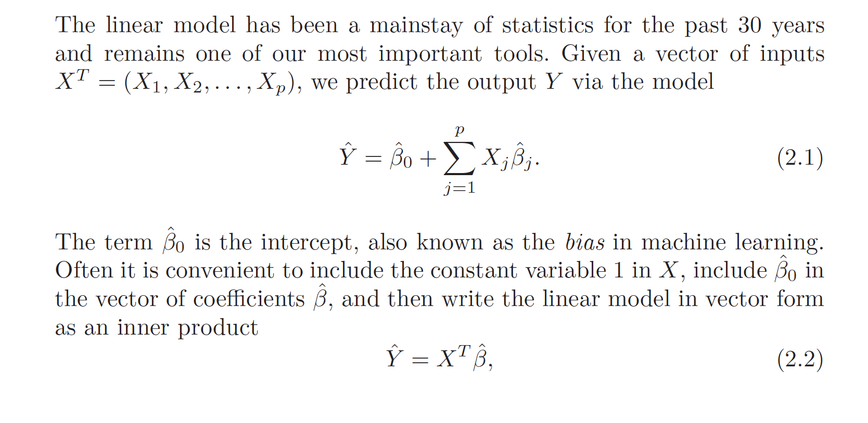

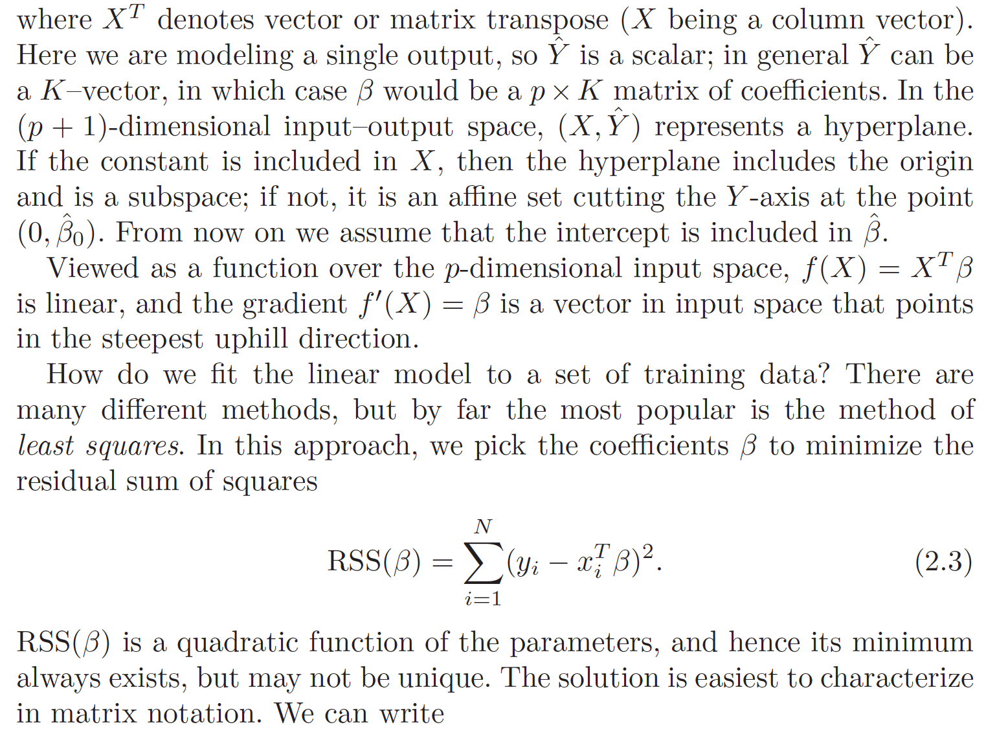

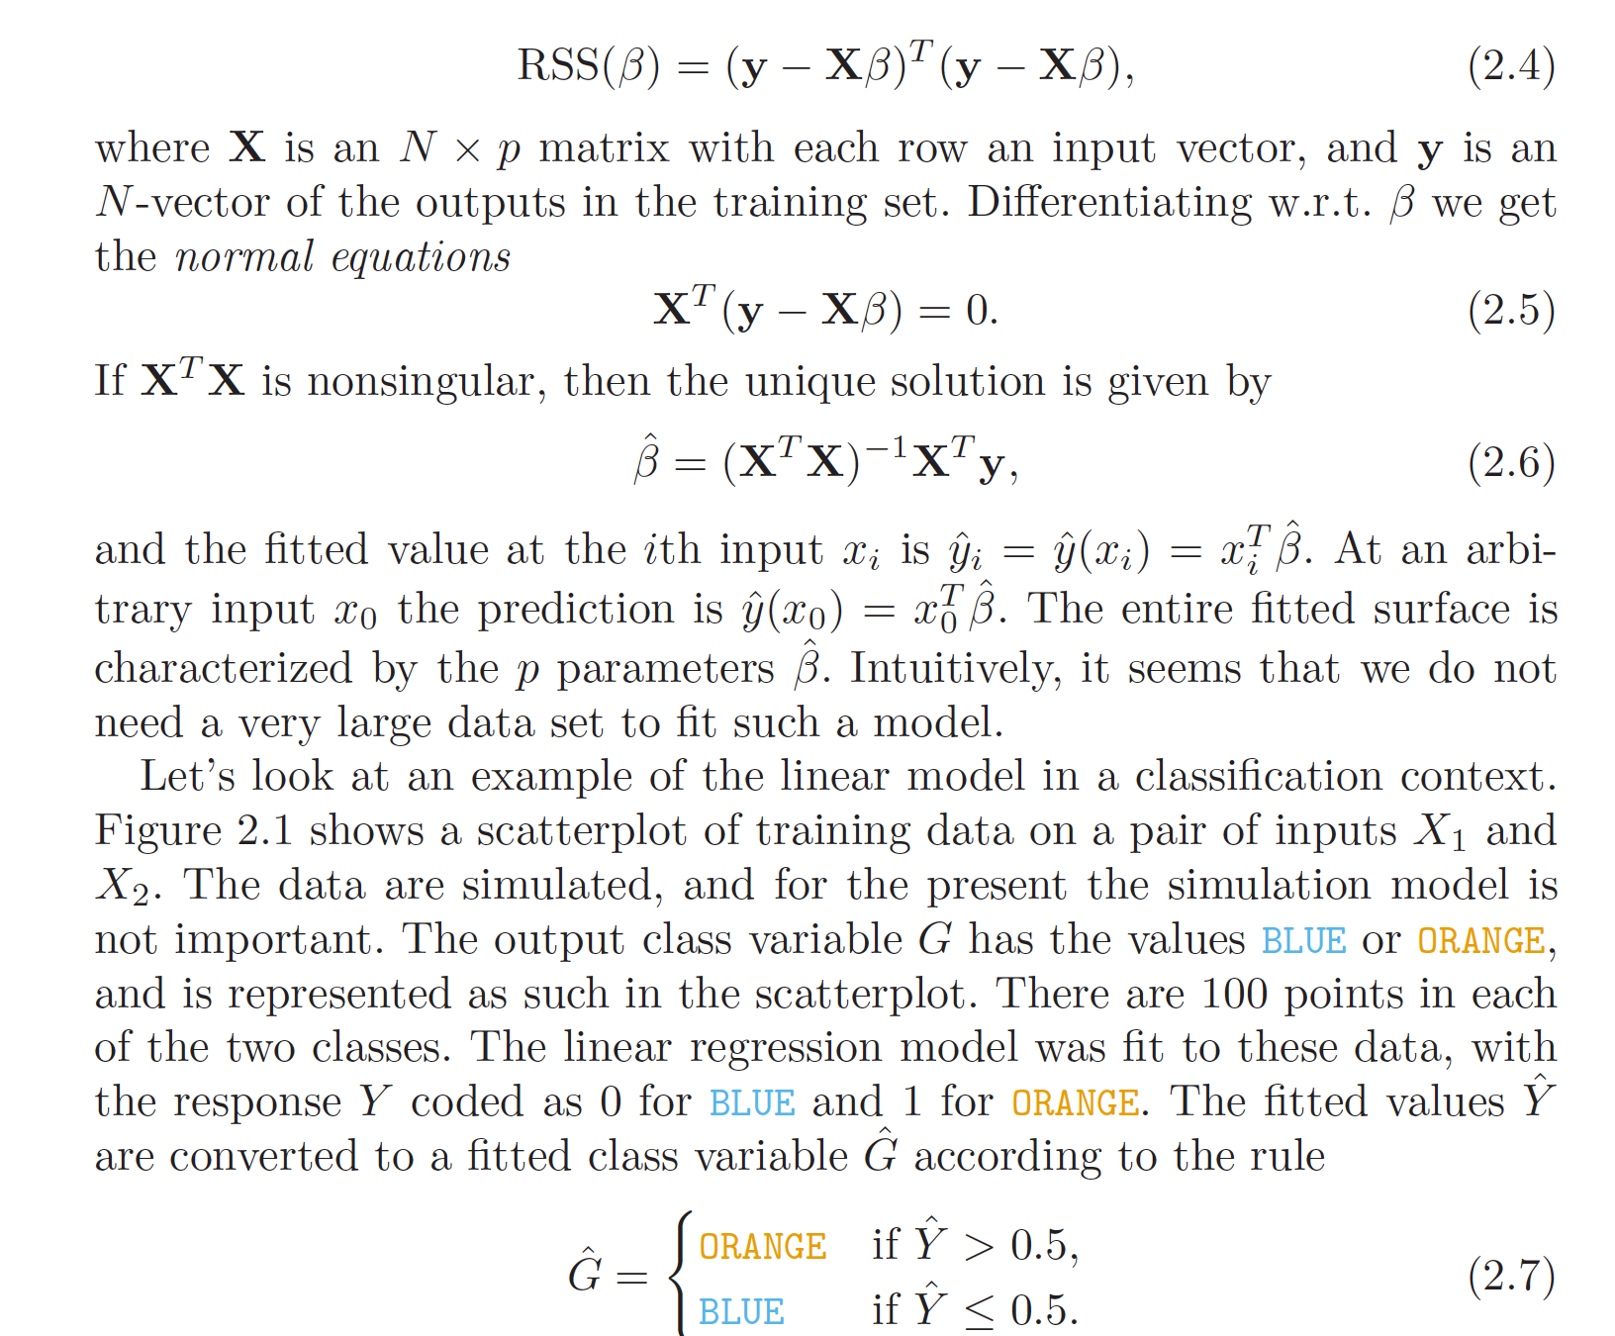

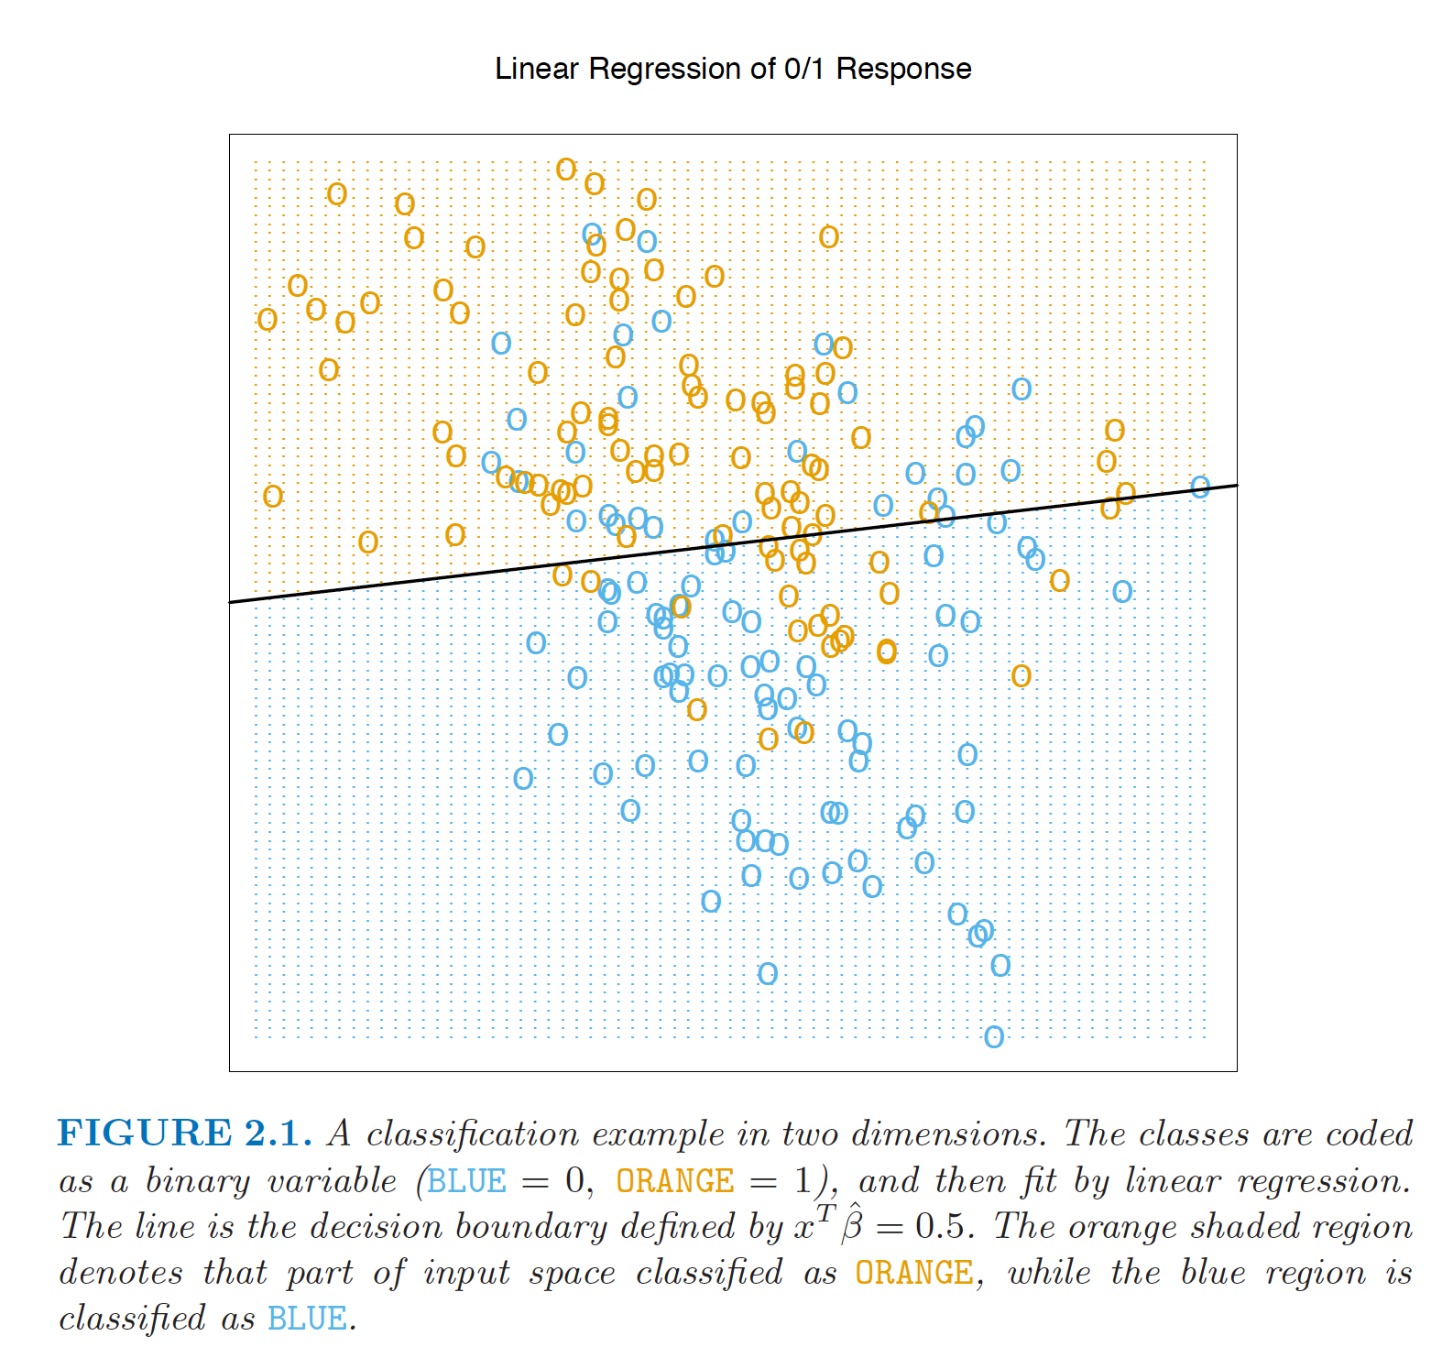

**Scenario 1:** The training data in each class were generated from bivariate Gaussian distributions with uncorrelated components and different means.

-- a linear decision boundary is the best one can do, and that our estimate is almost optimal. The region of overlap is inevitable, and future data to be predicted will be plagued by this overlap as well.

**Scenario 2:** The training data in each class came from a mixture of 10 low variance Gaussian distributions, with individual means themselves distributed as Gaussian.

-- In the case of mixtures of tightly clustered Gaussians the story is different. A linear decision boundary is unlikely to be optimal, and in fact is not. The optimal decision boundary is nonlinear and disjoint, and as such will be much more difficult to obtain.

**We now look at another classification and regression procedure that is in some sense at the opposite end of the spectrum to the linear model, and far better suited to the second scenario.**

* **Nearest Neighbors:**

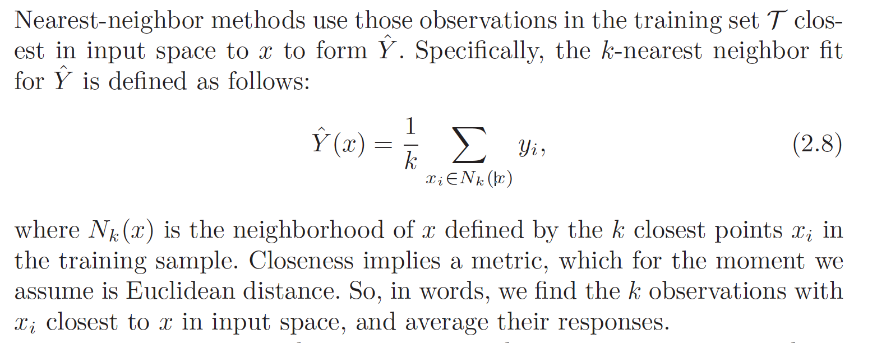

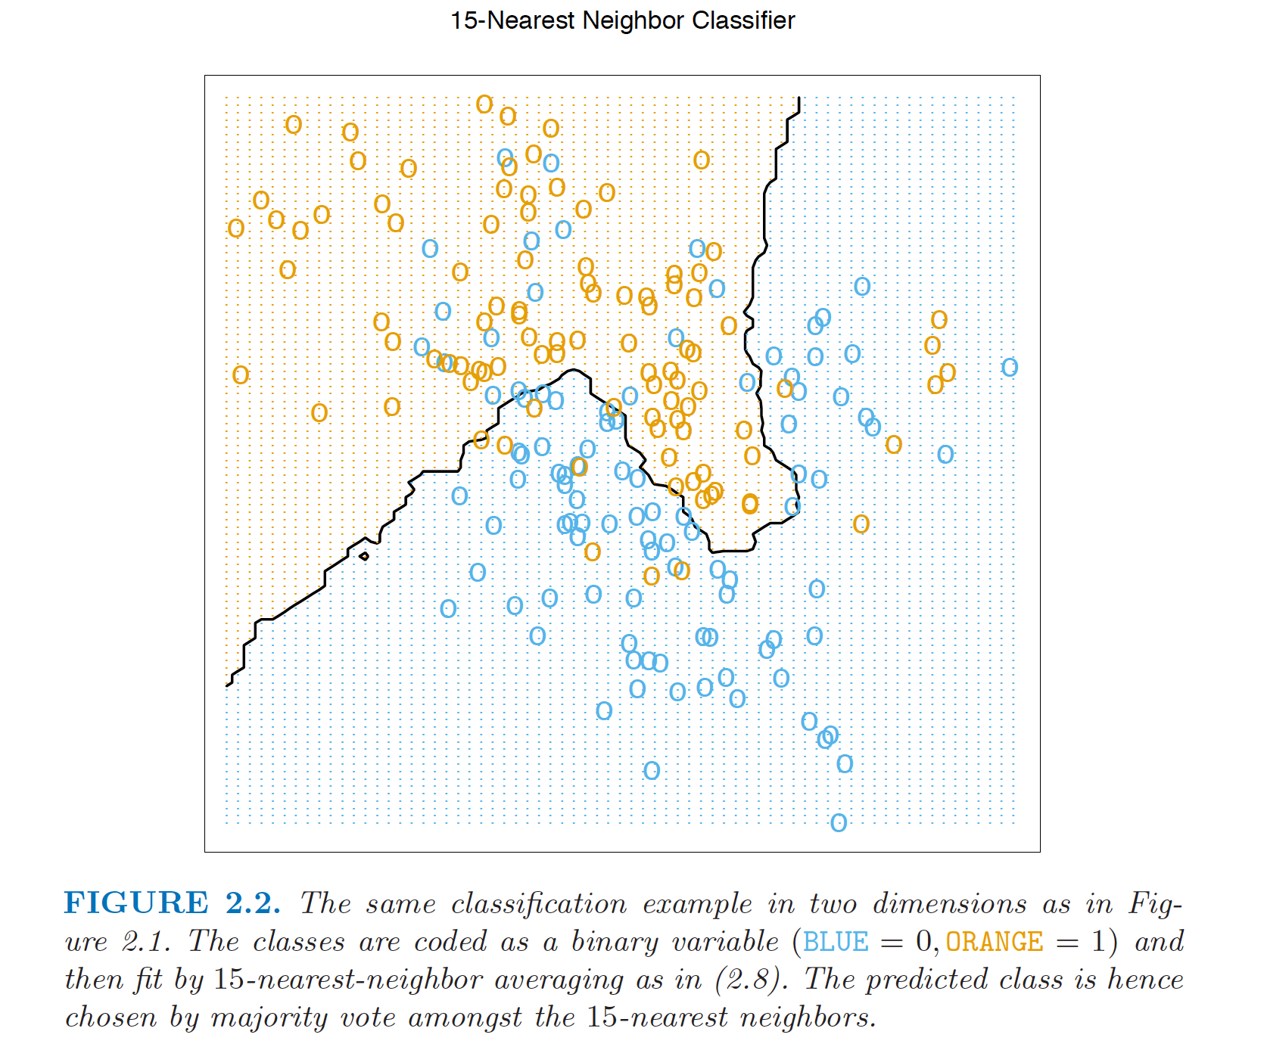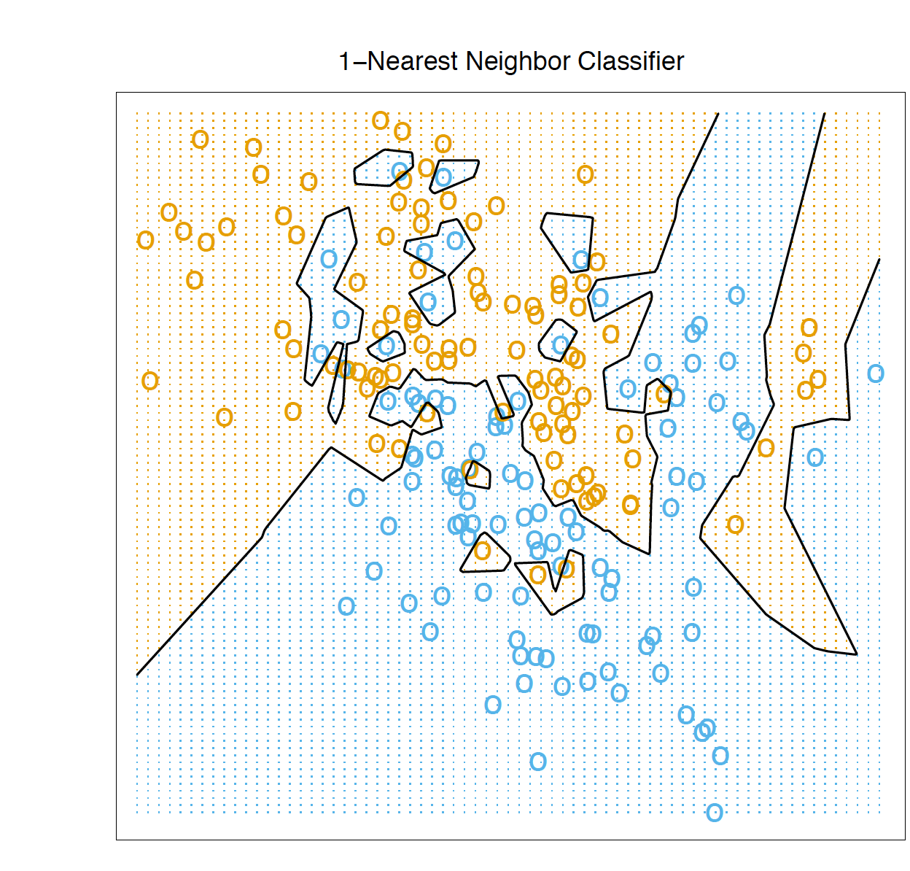

Least Squares v/s Nearest Neighbors

The linear decision boundary from least squares is very smooth, and apparently

stable to fit. It does appear to rely heavily on the assumption that a linear decision boundary is appropriate. In language we will develop shortly, it has **low variance and potentially high bias.**

On the other hand, the k -nearest-neighbor procedures do not appear to rely on any stringent assumptions about the underlying data, and can adapt to any situation. However, any particular subregion of the decision boundary depends on a handful of input points and their particular positions, and is thus wiggly and unstable, **high variance and low bias.**

\*\****Each method has its own situations for which it works best.***

**Introduction to statistical Learning:**

**Statistical learning refers to a vast set of tools for understanding data.**

The inputs go by different names, such as *predictors , independent variables , features or sometimes just variables* . The output variable—in this case, sales —is variable often called the response or dependent variable , and is typically denoted using the symbol Y.

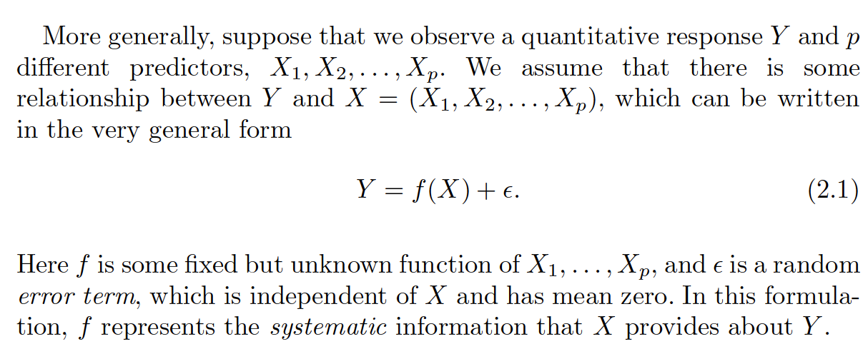

**In essence, statistical learning refers to a set of approaches for estimating $f$.**

**Why Estimate $f$?**

There are two main reasons that we may wish to estimate f : ***prediction*** and ***inference.***

* **Prediction**

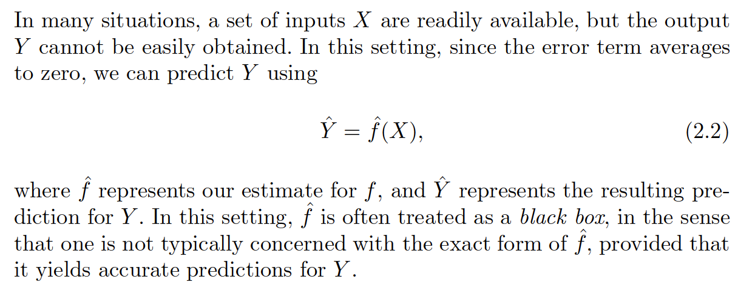

**Page 18:**

The accuracy of ˆ Y as a prediction for Y depends on two quantities, which we will call the ***reducible error and the irreducible error*** . In general,ˆ f will not be a perfect estimate for f , and this inaccuracy will introduce some error. This error is reducible because we can potentially improve the accuracy of ˆ f by using the most appropriate statistical learning technique to estimate f . However, even if it were possible to form a perfect estimate for f , so that our estimated response took the form ˆ Y = f (X ), our prediction would still have some error in it! This is because Y is also a function of $ϵ$, which, by definition, cannot be predicted using X . Therefore, variability associated with $ϵ$ also affects the accuracy of our predictions. This is known as the irreducible error, because no matter how well we estimate f , we cannot reduce the error introduced by .

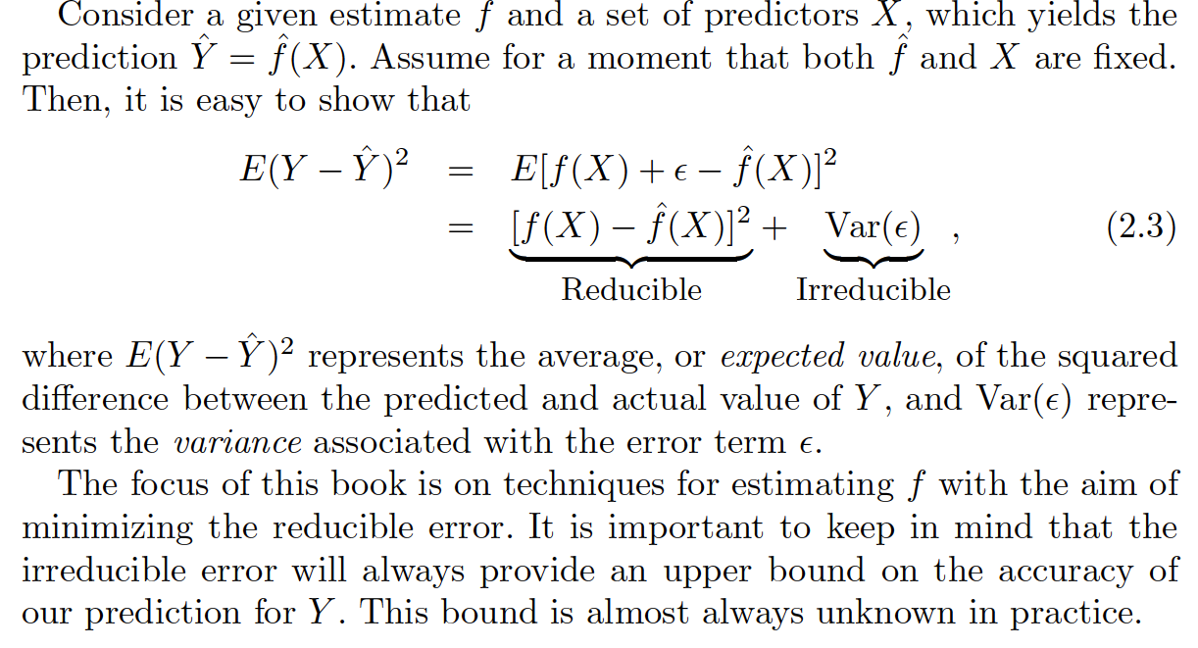

* **Inference**

We are often interested in understanding the way that Y is affected as X1, . . . , Xp change. In this situation we wish to estimate f , but our goal is not necessarily to make predictions for Y . We instead want to understand the relationship between X and Y , or more specifically, to understand how Y changes as a function of X1, . . .,Xp . Now (ˆ f) cannot be treated as a black box, because we need to know its exact form. In this setting, one may be interested in answering the following questions:

1. Which predictors are associated with the response?
2. What is the relationship between the response and each predictor?
3. Can the relationship between Y and each predictor be adequately summarized using a linear equation, or is the relationship more complicated?

Let’s say a company’s goal is to identify individuals who will respond positively to a mailing, based on observations of demographic variables measured on each individual. In this case, the demographic variables serve as predictors, and response to the marketing campaign (either positive or negative) serves as the outcome. The company is not interested in obtaining a deep understanding of the relationships between each individual predictor and the response; instead, the company simply wants an accurate model to predict the response using the predictors. This is an example of ***modeling for prediction.***

Another example involves modeling the brand of a product that a customer might purchase based on variables such as price, store location, discount levels, competition price,and so forth. In this situation one might really be most interested in how each of the individual variables affects the probability of purchase. For instance, what effect will changing the price of a product have on sales? This is an example of ***modeling for inference.***

Finally, some modeling could be conducted both for prediction and inference. For example, in a real estate setting, one may seek to relate values of homes to inputs such as crime rate, zoning, distance from a river, air quality, schools, income level of community, size of houses, and so forth. In this case one might be interested in how the individual input variables affect the prices—that is, *how much extra will a house be worth if it has a view of the river?*  This is an **inference problem.** Alternatively, one may simply be interested in predicting the value of a home given its characteristics: *is this house under- or overvalued?* This is a **prediction problem.**

**What kind of model, $f'$ should we choose for prediction or inference?**

Depending on whether our ultimate goal is prediction, inference, or a

combination of the two, different methods for estimating f may be appropriate.

For example, linear models allow for relatively simple and interpretable inference, but may not yield as accurate predictions as some other approaches. In contrast, some of the highly non-linear approaches that we discuss in the later chapters of this book can potentially provide quite accurate predictions for Y , but this comes at the expense of a less interpretable model for which inference is more challenging

**How do we estimate $f$?**

Most statistical learning methods for this task can be characterized as either parametric or non-parametric.

* **Parametric Methods:** Parametric methods involve a two-step model-based approach.

First, we make an assumption about the functional form, or shape, of ‘ $f$**’.** Whether it needs linear or more complex model

Second, After the model has been selected, we need a procedure that uses the training data to fit or train model.like, in the case of linear model we need to estimate the parameters for input variables in linear equation (i.e least square is one of many possible to fit the linear model.

Example : Smooth thin plate spline. Linear or lower order regressions

***Potential Disadvantage of parametric methods***: the model we choose will usually not match the true unknown form of f . If the chosen model is too far from the true f , then our estimate will be poor. We can try to address this problem by choosing

flexible models that can fit many different possible functional forms for f . But in general, fitting a more flexible model requires estimating a greater number of parameters. These more complex models can lead to a phenomenon known as ***overfitting*** the data, which essentially means they overfitting follow the errors, or noise , too closely.

* **Non Parametric methods:** Non-parametric methods do not make explicit assumptions about the functional form of $f$. Instead they seek an estimate of f that gets as close to the data points as possible without being too rough or wiggly $f$.

*Advantage* : By avoiding the assumption of a particular functional form for $f$, they have the potential to accurately fit a wider range of possible shapes for $f$

*Disadvantage:*  Since they do not reduce the problem of estimating f to a

small number of parameters, a very large number of observations (far more than is typically needed for a parametric approach) is required in order to obtain an accurate estimate for $f$. Also, it suffers from **overfitting**.

Example : Rough thin plate spline. KNN

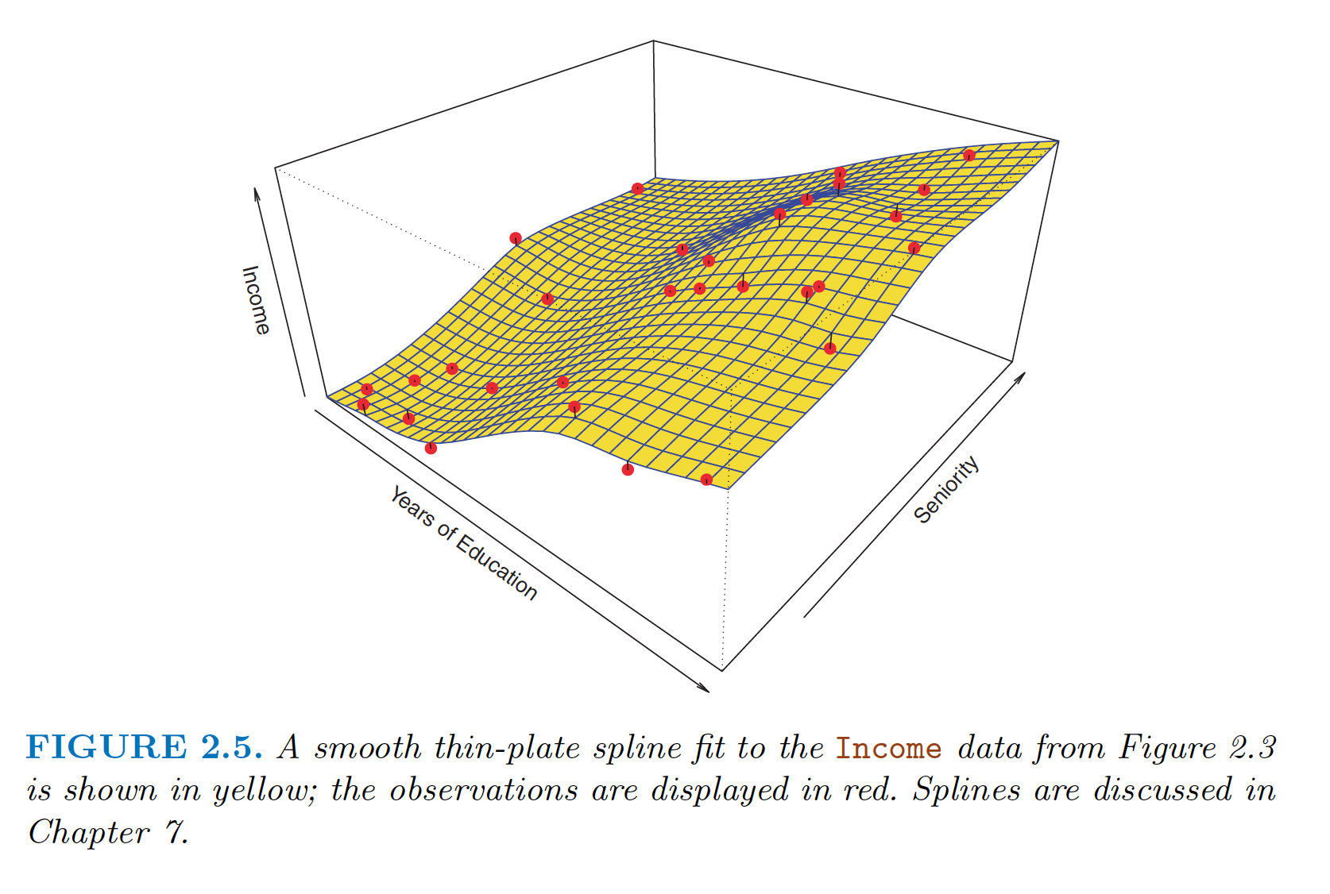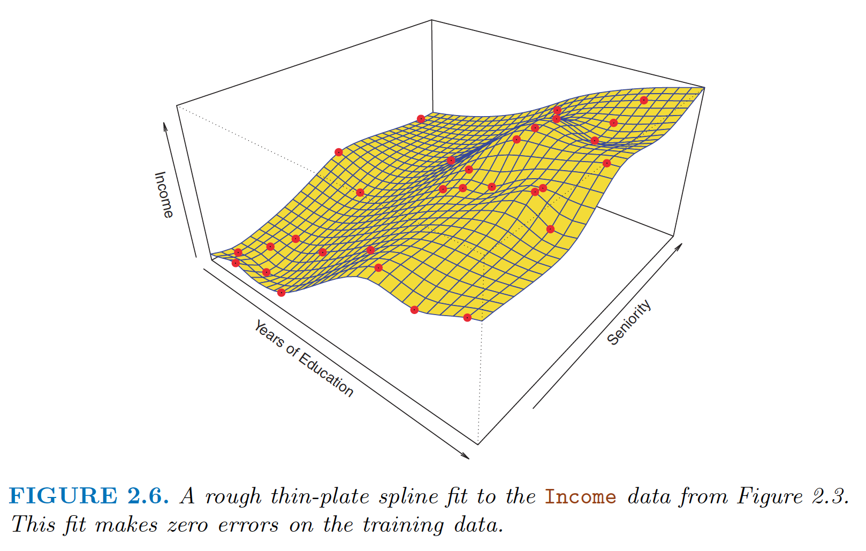

**The Trade-Off Between Prediction Accuracy and Model Interpretability :**

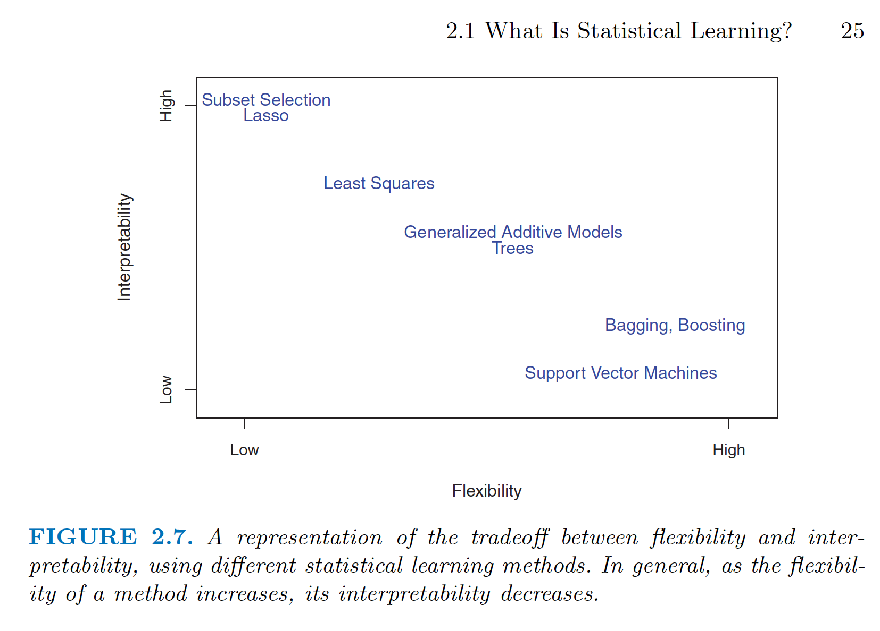

One might reasonably ask the following question: *why would we ever choose to use a more restrictive method instead of a very flexible approach?*

There are several reasons that we might prefer a more restrictive model.

If we are mainly interested in inference, then restrictive models are much

more interpretable.

In some settings, however, we are only interested in prediction, and the interpretability of the predictive model is simply not of interest. In this setting, we might expect that it will be best to use the most flexible model available. Surprisingly, this is not always the case! We will often obtain more accurate predictions using a less flexible method. This phenomenon, which may seem counterintuitive at first glance, has to do with the potential for overfitting in highly flexible methods.

**Supervised Versus Unsupervised Learning:**

*Supervised Learning* : For each observation of the predictor measurement(s) xi , i = 1, . . . , n there is an associated response measurement yi . We wish to fit a model that relates the response to the predictors, with the aim of accurately predicting the response for future observations (prediction) or better understanding the relationship between the response and the predictors (inference).

*Unsupervised Learning:*  For every observation i = 1, . . . , n , we observe a vector of measurements xi but no associated response yi . It is not possible to fit a linear regression model, since there is no response variable to predict. In this setting, we are in some sense working blind; the situation is referred to as unsupervised because we lack a response variable that can supervise our analysis.

*Semi-Supervised Learning:*  For instance, suppose that we have a set of n observations. For m of the observations, where m < n , we have both predictor measurements and a response measurement. For the remaining n − m observations, we have predictor measurements but no response measurement. Such a scenario can arise if the predictors can be measured relatively cheaply but the corresponding responses are much more expensive to collect. We refer to this setting as a semi-supervised learning problem. In this setting, we wish to use a statistical learning method that can incorporate the m observations for which response measurements are available as well as the n −m observations for which they are not.

**Regression v/s Classification:**

We tend to refer to problems with a quantitative response as regression problems, while those involving a qualitative response are often referred to as classification problems.However, the distinction is not always that crisp. Least squares linear regression is used with a quantitative response, whereas logistic regression (Chapter 4) is typically used with a qualitative (two-class, or binary ) response. As such it is often used as a classification method. But binary since it estimates class probabilities, it can be thought of as a regression method as well. Some statistical methods, such as K -nearest neighbors and boosting can be used in the case of either quantitative or qualitative responses.

We tend to select statistical learning methods on the basis of whether the response is quantitative or qualitative. **“However, whether the predictors are qualitative or quantitative is generally considered less important.”**

**Assessing Model Accuracy (For regression setting):**

It is an important task to decide for any given set of data which method produces the best results. Selecting the best approach can be one of the most challenging parts of performing statistical learning in practice.

**Measuring the Quality of Fit:** We need to quantify the extent to which the predicted response value for a given observation is close to the true response value for that observation. In the regression setting, the most commonly-used measure is the mean squared error (MSE), given by

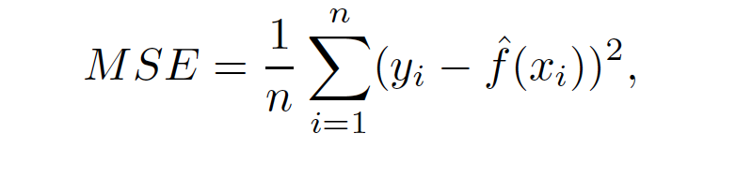

**The *degrees of freedom* is a quantity that summarizes the *flexibility* of a curve.**

A more restricted and hence smoother curve has fewer degrees of freedom than a wiggly curve. linear regression is at the most restrictive end, with two degrees of freedom. The training MSE declines monotonically as flexibility increases. In this example the true f is non-linear, and so the orange linear fit is not flexible enough to estimate f well. The green curve has the lowest training MSE of all three methods, since it corresponds to the most flexible of the three curves fit in the left-hand panel.

As model flexibility increases, training MSE will decrease, but the test MSE may not. When a given method yields a small training MSE but a large test MSE, we are said to be overfitting the data. This happens because our statistical learning procedure is working too hard to find patterns in the training data, and may be picking up some patterns that are just caused by random chance rather than by true properties of the unknown function f .

***Overfitting :*** Overfitting refers specifically to the case in which a less flexible model would have yielded a smaller test MSE than more flexible model.

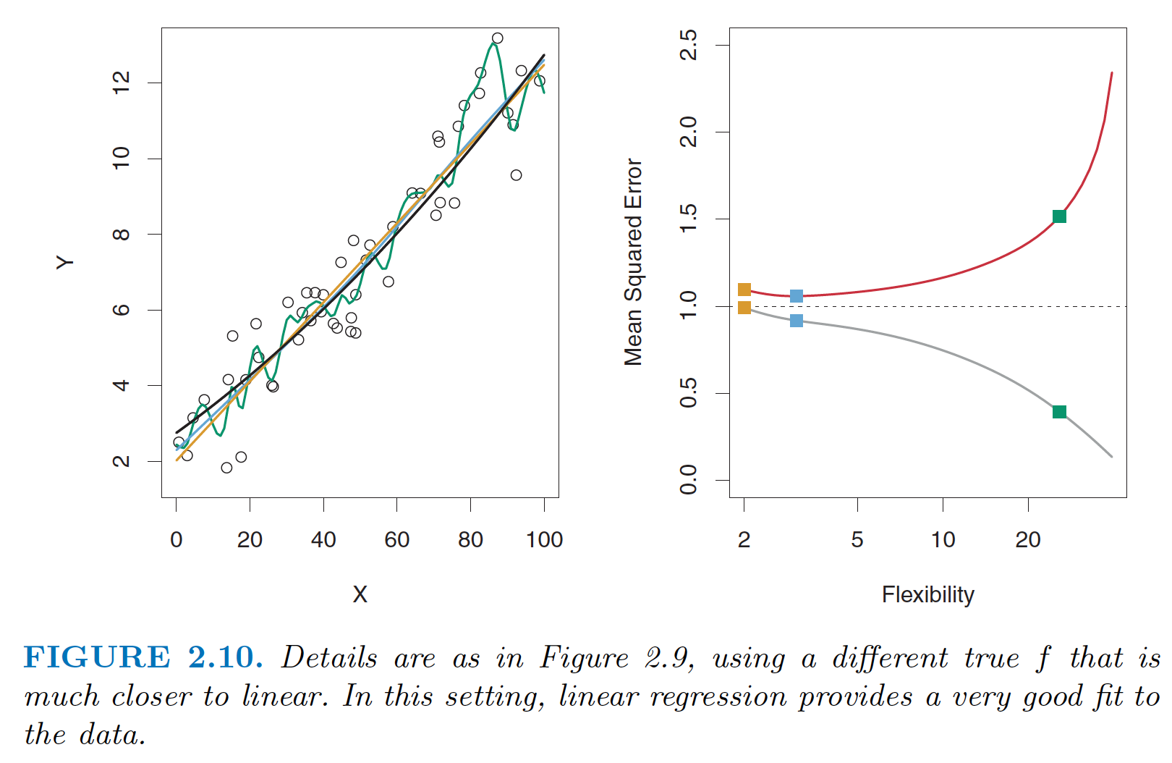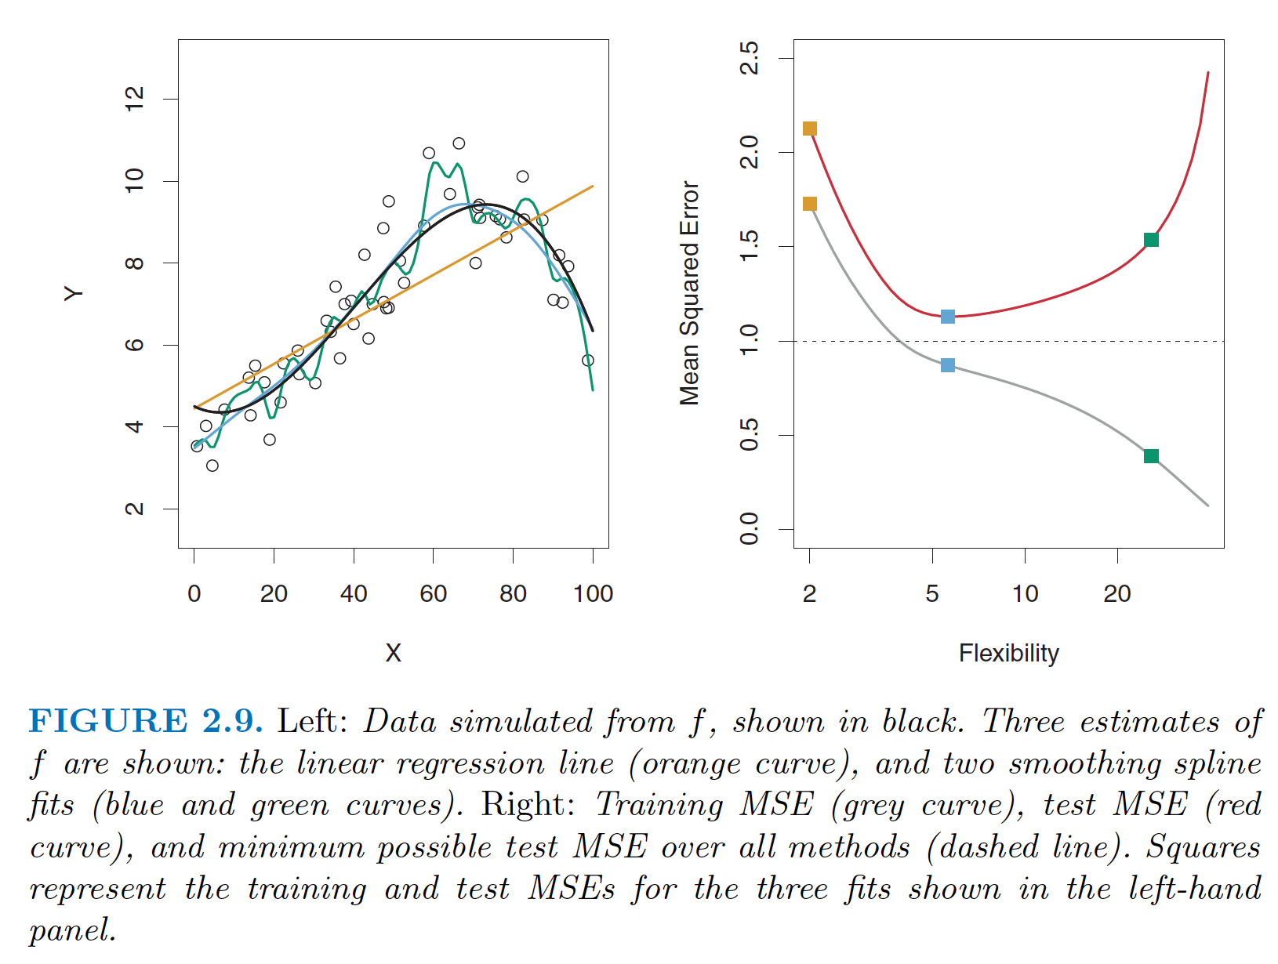

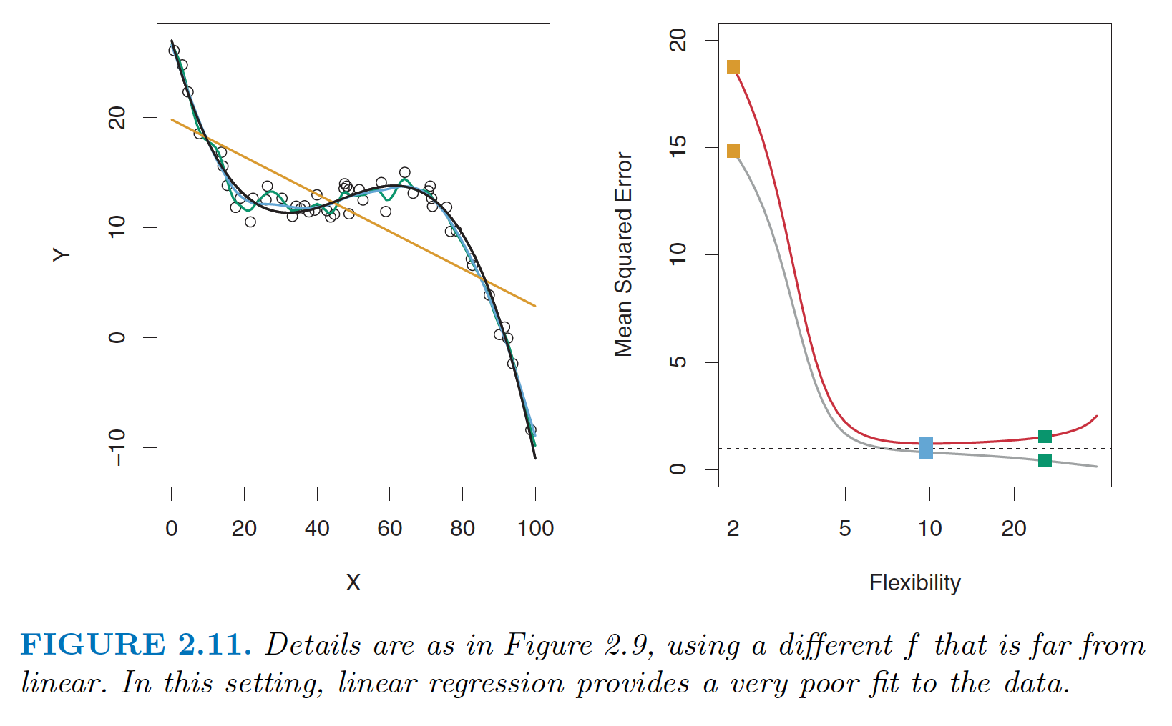

**The Bias-Variance Trade-Off:**

The expected test MSE, for a given value x0 , can

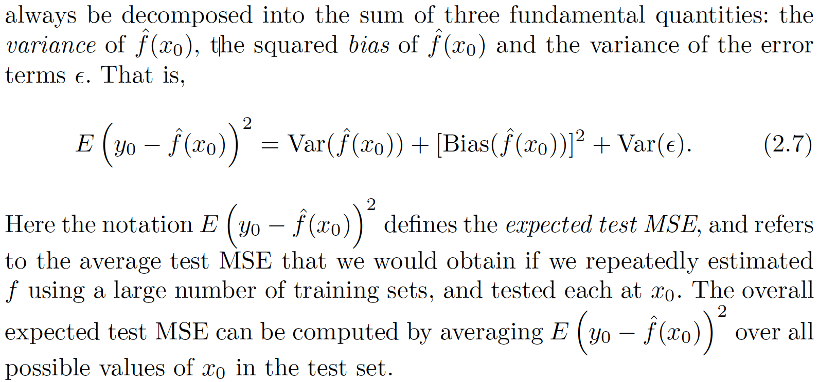

***Variance:*** refers to the amount by which ˆ $f$ would change if we estimated it using a different training data set. Since the training data are used to fit the statistical learning method, different training data sets will result in a different ˆ $f$. But ideally the estimate for $f$ should not vary too much between training sets. However, if a method has high variance then small changes in the training data can result in large changes in ˆ $f$. ***In general, more flexible statistical methods have higher variance*.** Consider the green and orange curves in Figure 2.9. The flexible green curve is following the observations very closely. It has high variance because changing any one of these data points may cause the estimate ˆ $f$ to change considerably. In contrast, the orange least squares line is relatively inflexible and has low variance, because moving any single observation will likely cause only a small shift in the position of the line.

***Bias:***  The error that is introduced by approximating a real-life problem, which may be extremely complicated, by a much simpler model. For example, linear regression assumes that there is a linear relationship between Y and X1,X2, . . . , Xp . It is unlikely that any real-life problem truly has such a simple linear relationship, and so performing linear regression will undoubtedly result in some bias in the estimate of f . In Figure 2.11, the true f is substantially non-linear, so no matter how many training observations we are given, it will not be possible to produce an accurate estimate using linear regression. In other words, linear regression results in high bias in this example. However, in Figure 2.10 the true f is very close to linear, and so given enough data, it should be possible for linear regression to produce an accurate estimate.

***Generally, more flexible methods result in less bias.***

***As a general rule, as ***we use more flexible methods, the variance will increase and the bias will decrease.*** The relative rate of change of these two quantities determines whether the test MSE increases or decreases. As we increase the flexibility of a class of methods, the bias tends to initially decrease faster than the variance increases. Consequently, the expected test MSE declines. However, at some point increasing flexibility has little impact on the bias but starts to significantly increase the variance. When this happens the test MSE increases. Note that we observed this pattern of decreasing test MSE followed by increasing test MSE in the right-hand panels of Figures 2.9–2.11.

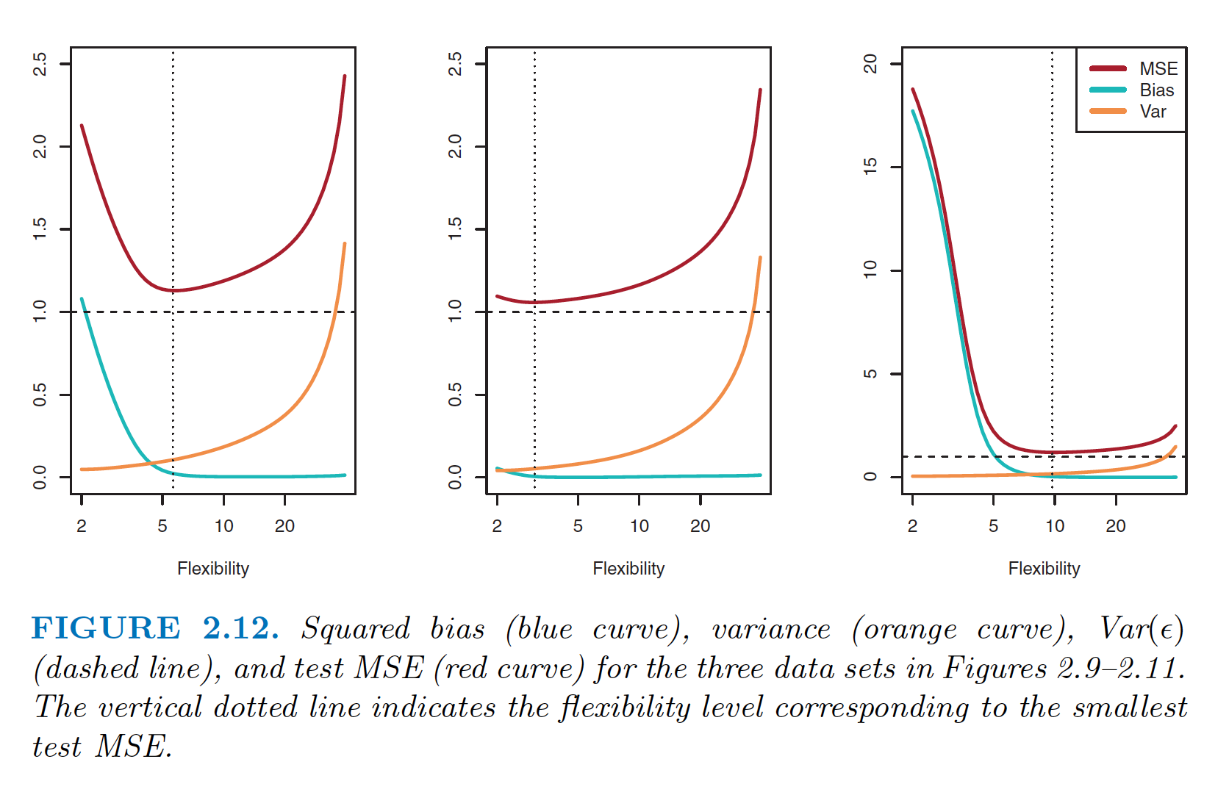

The horizontal dashed line represents Var( $ϵ$), the irreducible error.

The relationship between bias, variance, and test set MSE given in Equation 2.7 and displayed in Figure 2.12 is referred to as the ***bias-variance trade-off*** . Good test set performance of a statistical learning method requires low variance as well as low squared bias.

In a real-life situation in which f is unobserved, it is generally not possible to explicitly compute the test MSE, bias, or variance for a statistical learning method. Nevertheless, one should always keep the bias-variance trade-off in mind. Read ***cross-validation*** in future slides, which is a way to estimate the test MSE using the training data.

**Assessing Model Accuracy (For classification setting):**

**Error rate:**

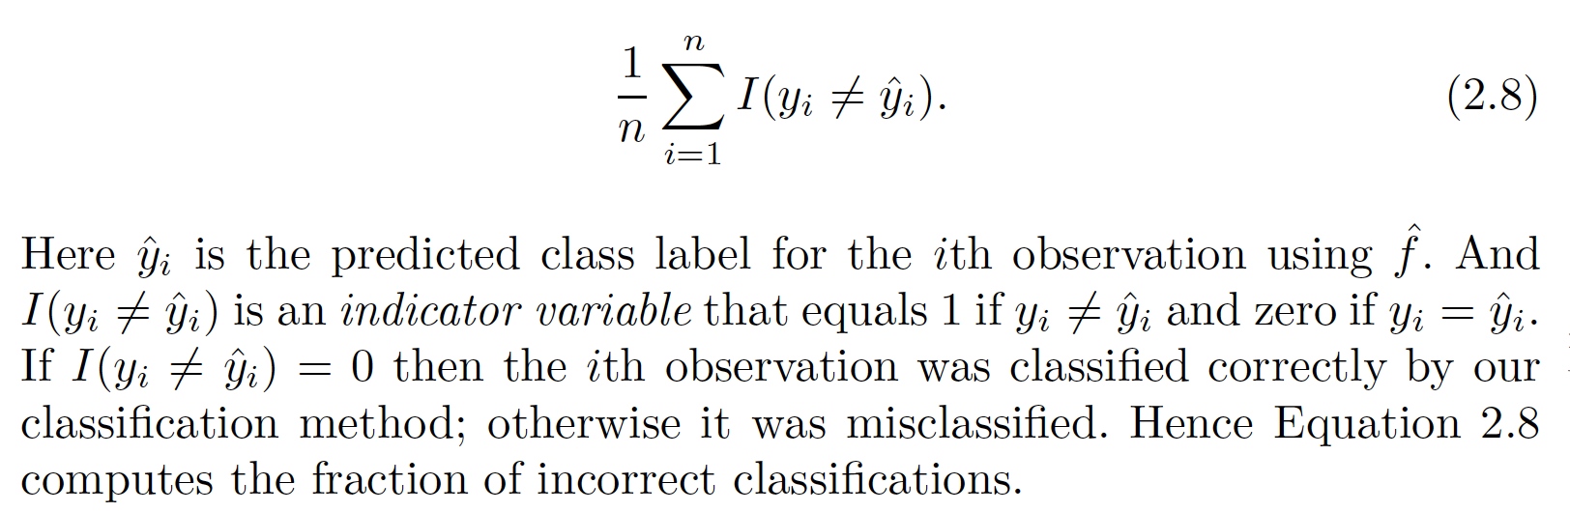

**The Bayes Classifier:**

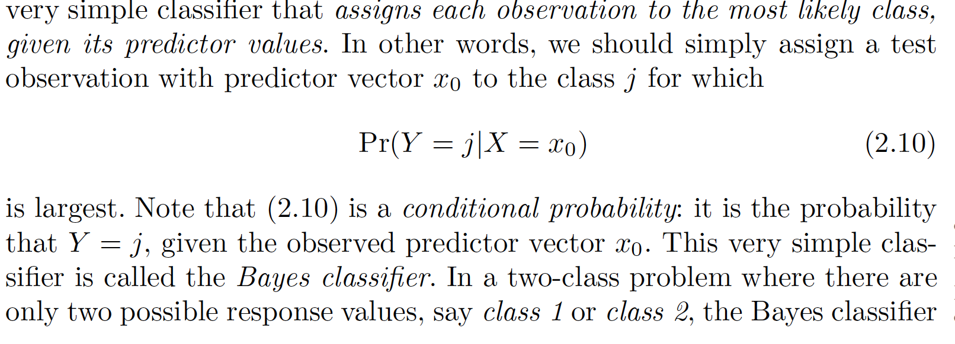

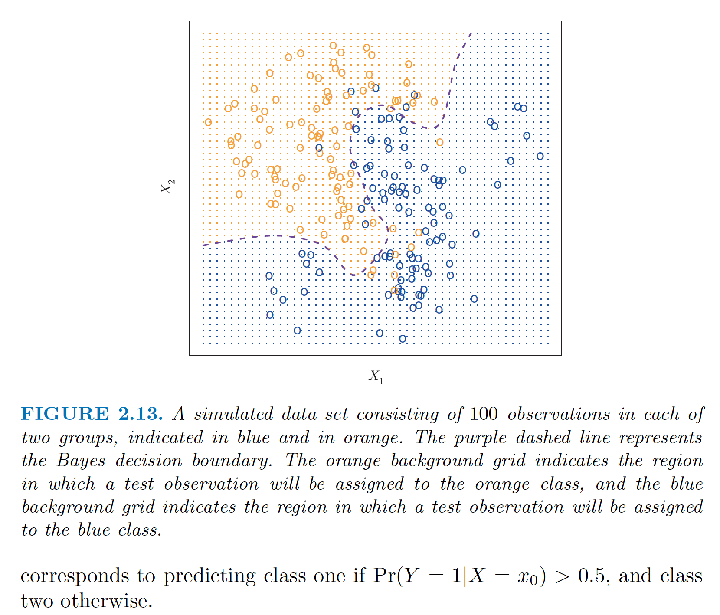

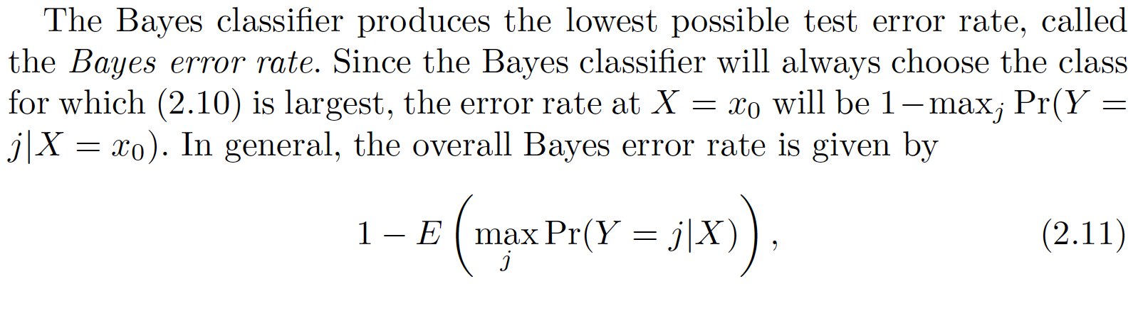

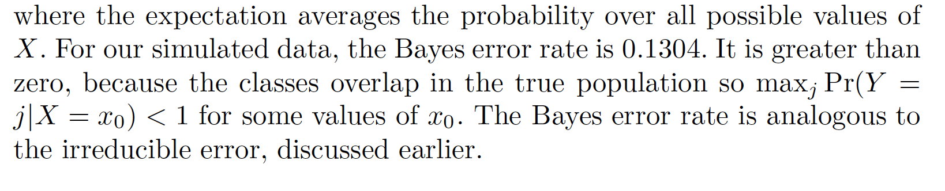

*In theory we would always like to predict qualitative responses using the Bayes classifier.* ***But for real data, we do not know the conditional distribution of Y given X , and so computing the Bayes classifier is impossible.*** *Therefore, the Bayes classifier serves as an unattainable gold standard against which to compare other methods. Many approaches attempt to estimate the conditional distribution of Y given X , and then classify a given observation to the class with highest estimated probability. One such method is the K-nearest neighbors (KNN) classifier.*

**K-Nearest Neighbors:**

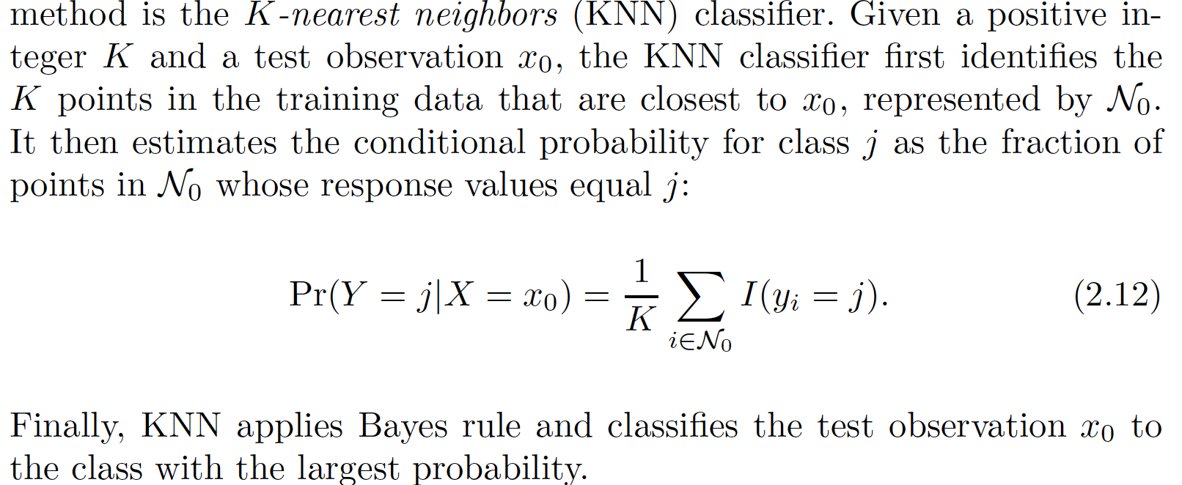

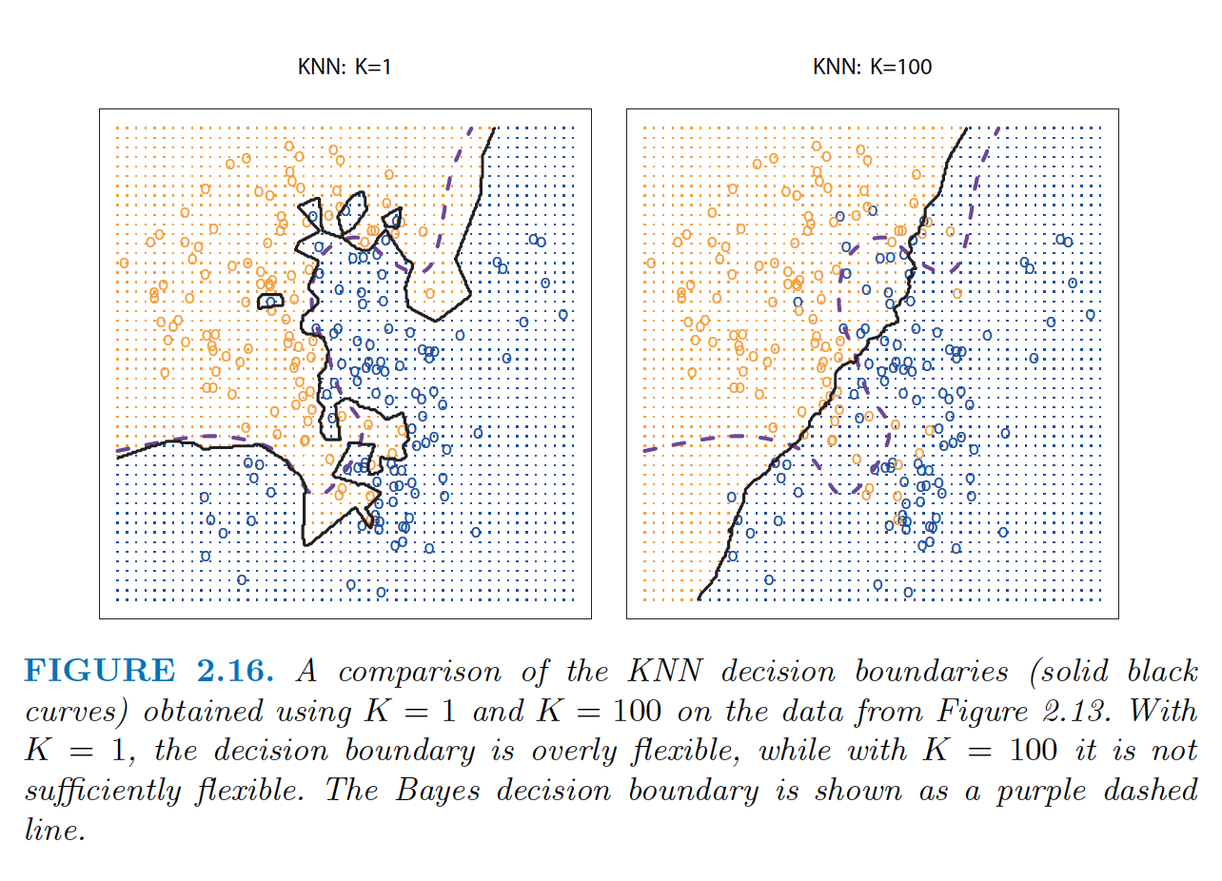

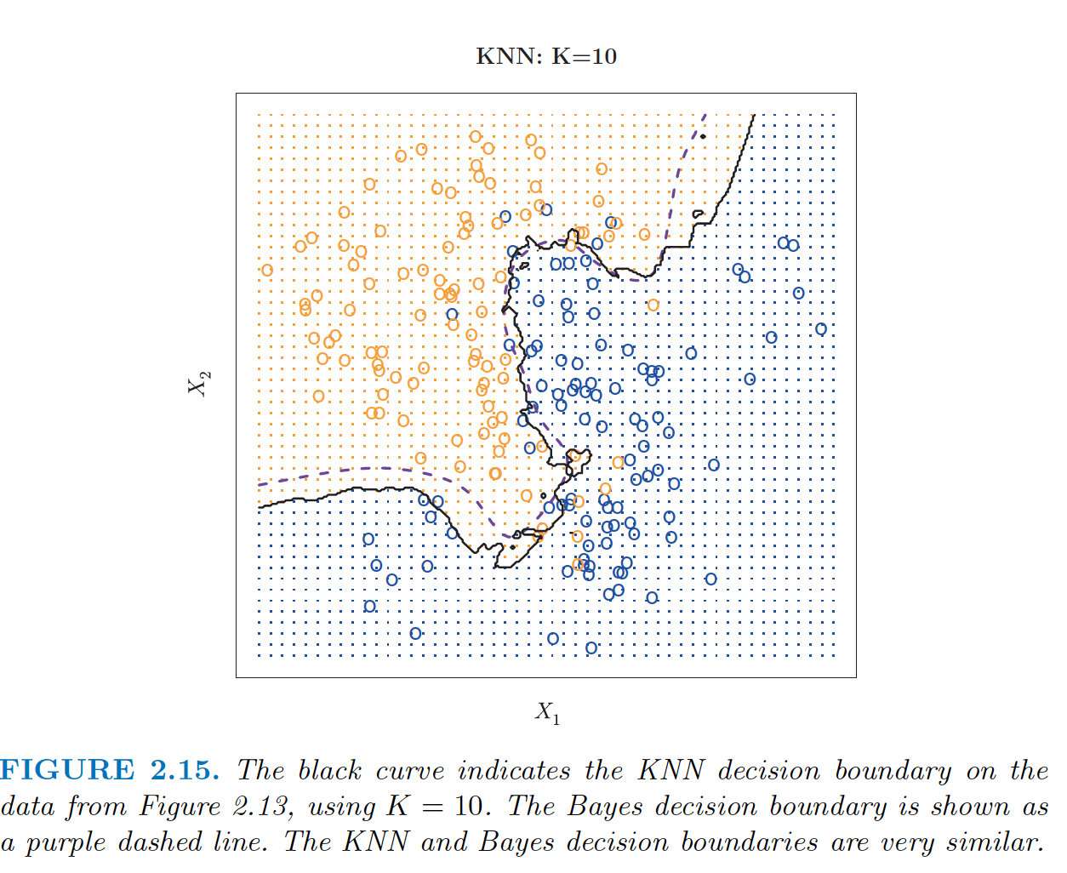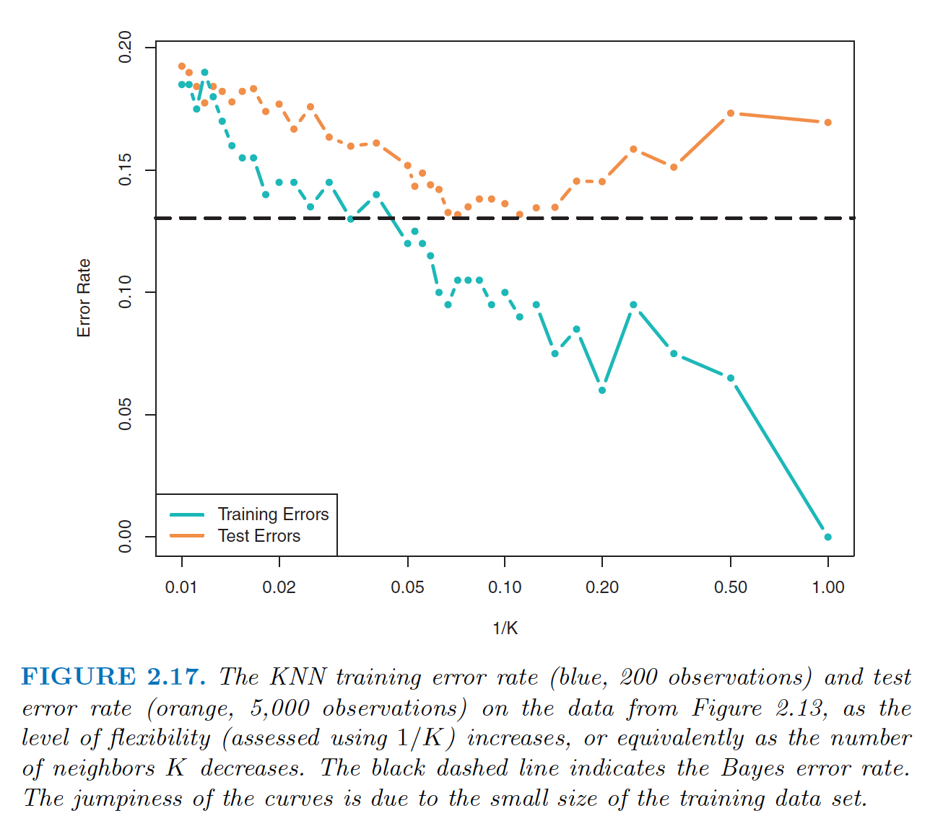

In both the regression and classification settings, choosing the correct level of flexibility is critical to the success of any statistical learning method. The bias-variance tradeoff, and the resulting U-shape in the test error, can make this a difficult task. In Chapter 5, we return to this topic and discuss various methods for estimating test error rates and thereby choosing the optimal level of flexibility for a given statistical learning method.

**Chapter 3-Linear Regression:**

**Simple Linear Regression:** It is a very straightforward simple linear approach for predicting a quantitative response Y on the basis of a single predictor variable X . It assumes that there is approximately a linear relationship between X and Y . Mathematically, we can write this linear relationship as

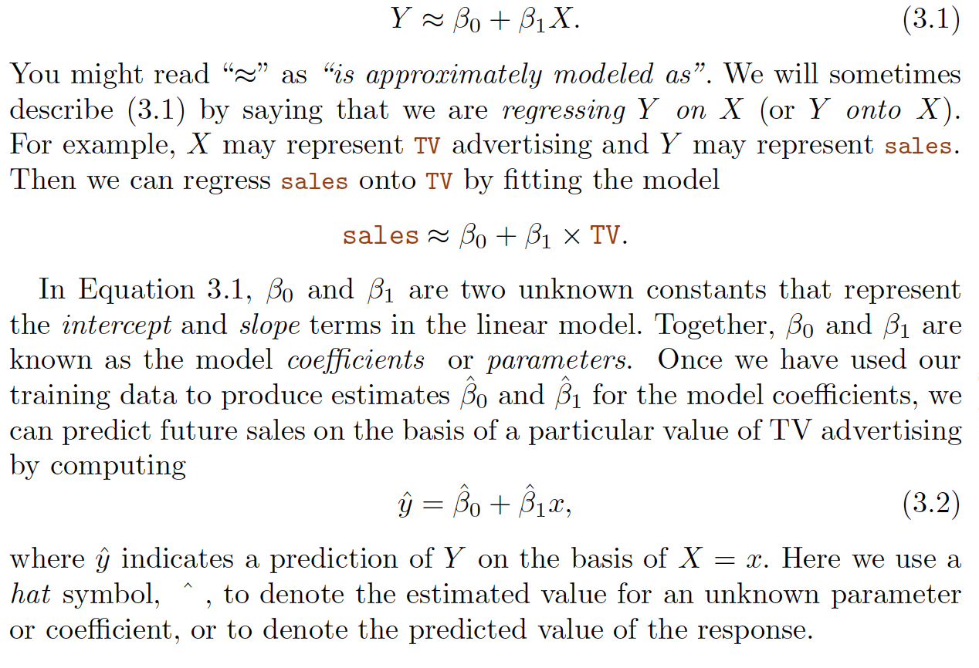

*\*\*****Advertising data*** *from Chapter 2. Figure 2.1 displays sales (in thousands of units) for a particular product as a function of advertising budgets (in thousands of dollars) for TV, radio, and newspaper media.*

We want to find an intercept $\hat{β}{}_{0}$ and a slope $\hat{β}{}_{1}$ such that resulting line is as close as possible to training points. By far the common approach is ‘least squares’.

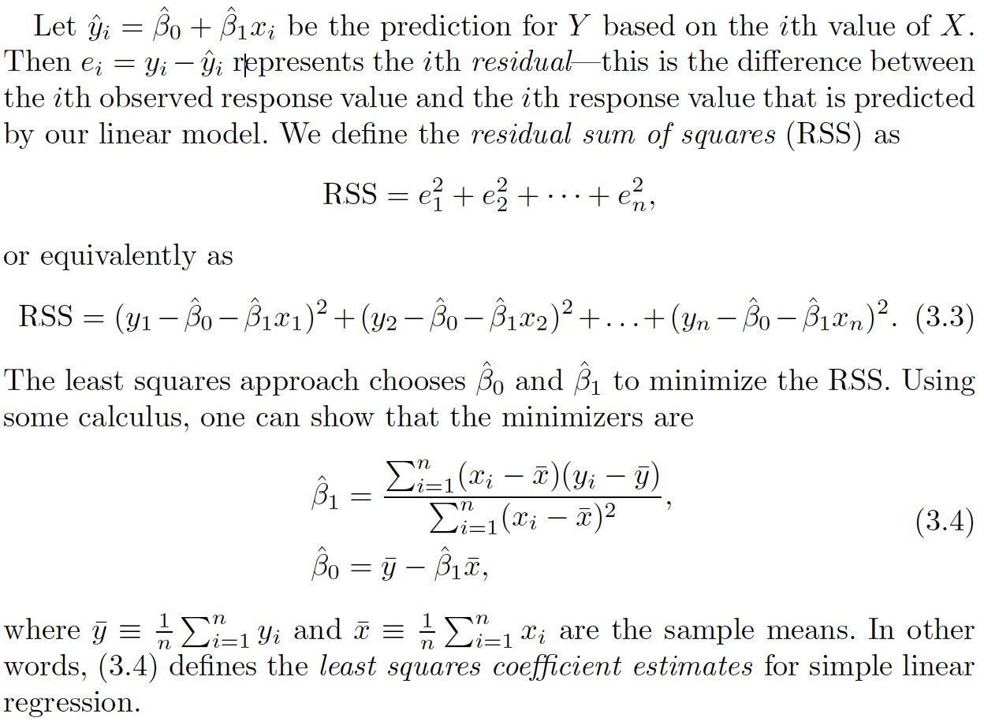

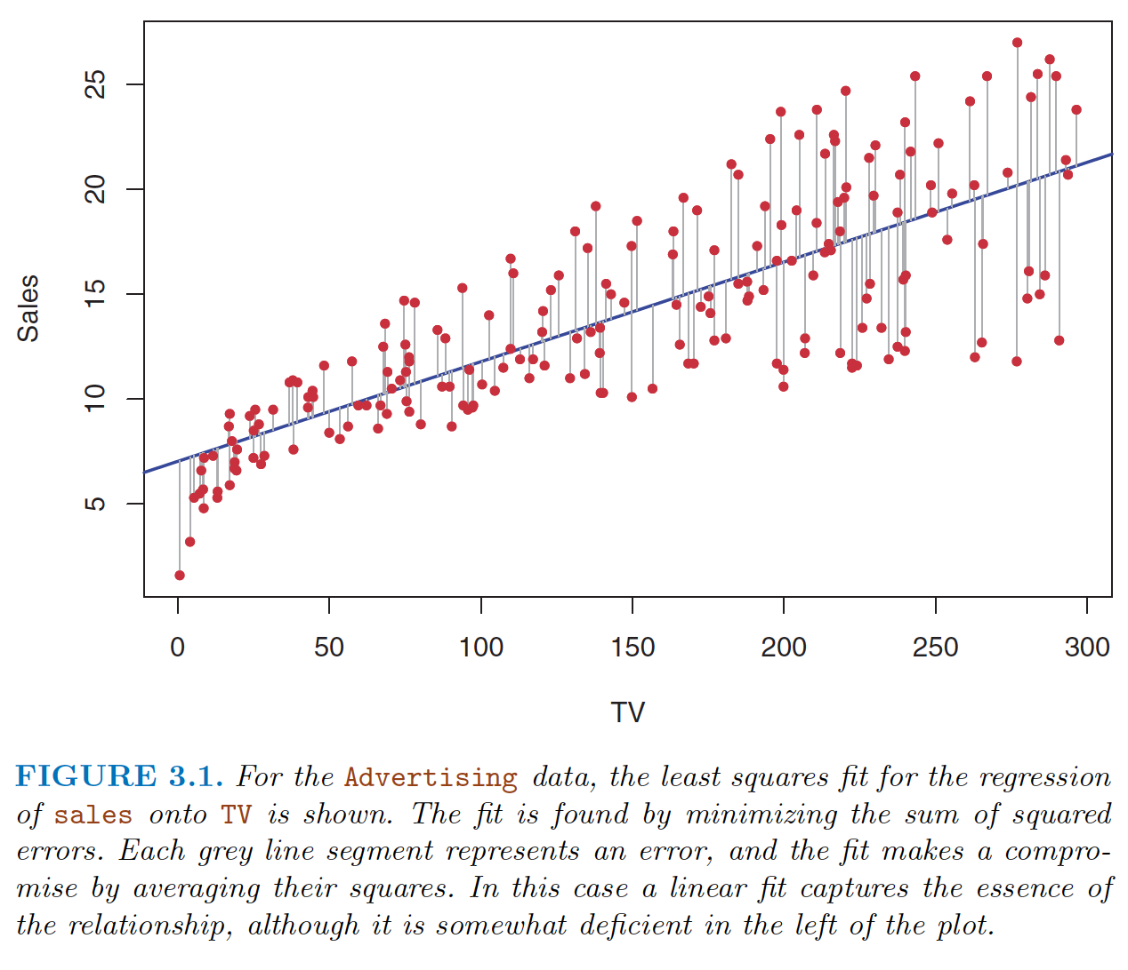

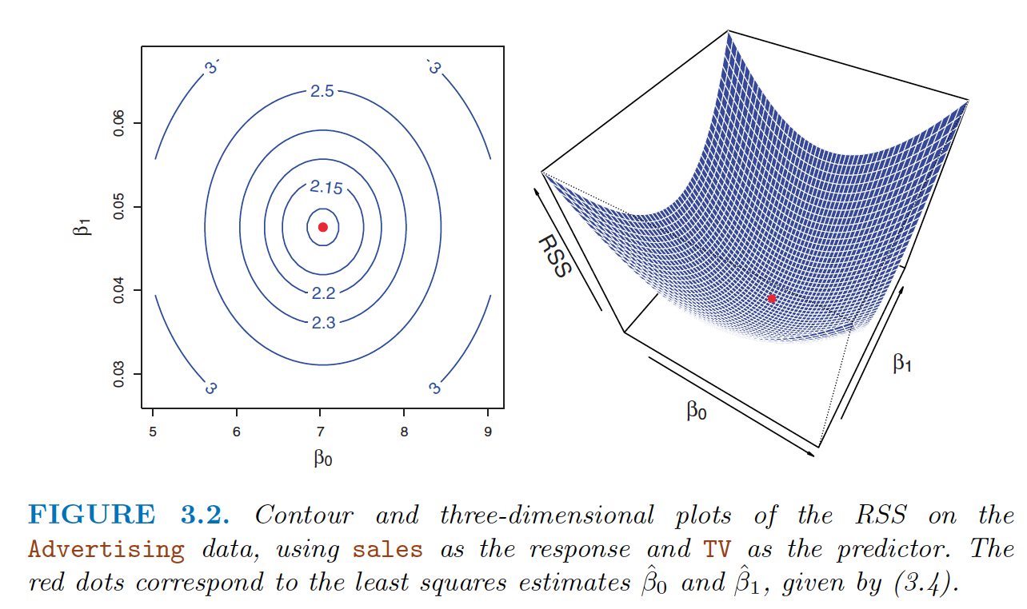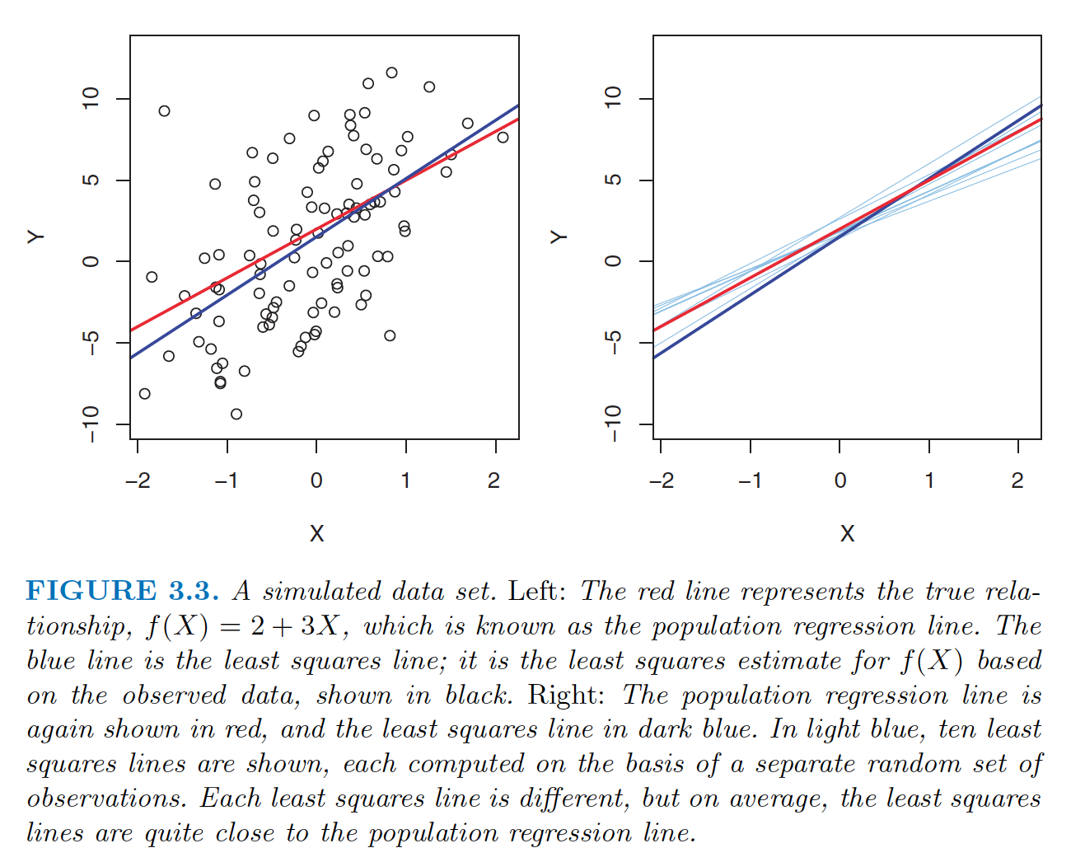

The true relationship is generally not known for real data, but the least squares line can always be computed using the coefficient estimates.

The **population regression line** , which is the best linear approximation to the true relationship between X and Y . The least squares regression coefficient estimates (3.4) characterize the **least squares line.**

In the right-hand panel of Figure 3.3 we have generated ten different data sets from the model given by (3.6) and plotted the corresponding ten least squares lines. Notice that different data sets generated from the same true model result in slightly different least squares lines, but the unobserved population regression line does not change.

Let say we have only access to one dataset (one sample from population) so we have only one least square line to estimate characteristics of a large population.

Fundamentally, the concept of these two lines is a natural extension of the standard statistical

approach of using information from a sample to estimate characteristics of a large population.

For example, we are interested in knowing the population mean μ of some random variable Y .

Since we don’t have access to the population, but we have access to a sample of n observation from Y. A reasonable estimate is ${}_{}^{^}μ\text{= mean(y)}$ i.e. mean of observations of sample Y. In the same way, the unknown coefficients β0 and β1 in linear regression define the population regression line.We seek to estimate these unknown coefficients using ˆ β0 and ˆ β1 given in (3.4). These coefficient estimates define the least squares line.

The analogy between linear regression and estimation of the mean of a random variable is an apt one based on the concept of bias . If we use the sample mean ˆμ to estimate μ , this estimate is unbiased , in the sense that unbiased on average, we expect ˆμ to equal μ . What exactly does this mean? It means that on the basis of one particular set of observations y1, . . . , yn , ˆμ might overestimate μ , and on the basis of another set of observations, ˆμ might underestimate μ . But if we could average a huge number of estimates of μ obtained from a huge number of sets of observations, then this average would exactly equal μ . Hence, an unbiased estimator does not systematically over- or under-estimate the true parameter. The property of unbiasedness holds for the least squares coefficient estimates given by (3.4) as well: if we estimate β0 and β1 on the basis of a particular data set, then our estimates won’t be exactly equal to β0 and β1 . But if we could average the estimates obtained over a huge number of data sets, then the average of these estimates would be spot on! In fact, we can see from Figure 3.3 that the average of many least squares lines, each estimated from a separate data set, is pretty close to the true population regression line.

**Standard Error:**

We continue the analogy with the estimation of the population mean μ of a random variable Y . A natural question is as follows: how accurate is the sample mean ˆμ as an estimate of μ ? We have established that the average of ˆμ ’s over many data sets will be very close to μ , but that a

single estimate ˆμ may be a substantial underestimate or overestimate of μ . How far off will that single estimate of ˆμ be? In general, we answer this question by computing the **standard error** of ˆμ , written as SE(ˆμ ). We have standard the well-known formula error

Var(ˆμ ) = SE(ˆμ )2 = σ2/n, (3.7)

* The standard error tells us the average amount that thisestimate ˆμ differs from the actual value of μ .
* This deviation shrinks with n —the more observations we have, the smaller the standard error of ˆμ .

In a similar vein, we can wonder how close ˆ β0 and ˆ β1 are to the true values β0 and β1 . To compute the standard errors associated with ˆβ0 and ˆ β1 , we use the following formulas

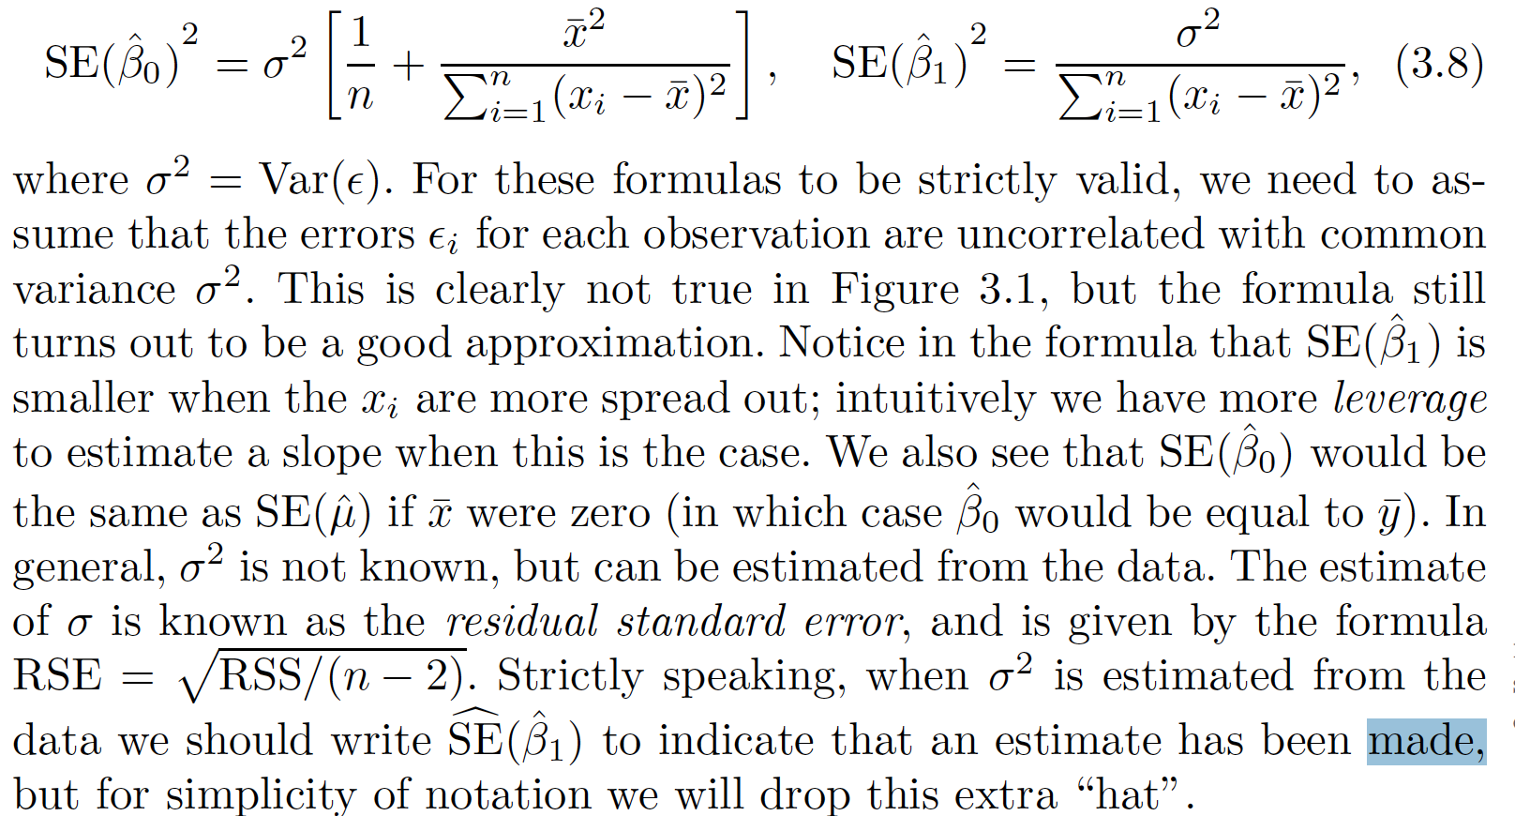

**Confidence Interval:**

Standard errors can be used to compute confidence intervals . A 95% confidence interval is defined as a range of values such that with 95% interval probability, the range will contain the true unknown value of the parameter. The range is defined in terms of lower and upper limits computed from the sample of data. For linear regression, the 95% confidence interval for β1

approximately takes the form

[**ˆ β1 - 2 . SE( ˆ β1 ) - ˆ β1 + 2 . SE( ˆ β1 )]**

Example for confidence interaval : In the case of the advertising data, the 95% confidence interval for β0 is [6. 130, 7. 935] and the 95% confidence interval for β1 is [0. 042, 0. 053]. Therefore, we can conclude that in the absence of any advertising, sales will, on average, fall somewhere between 6, 130 and 7, 940 units. Furthermore, for each $1, 000 increase in television advertising, there will be an average increase in sales of between 42 and 53 units.

**Hypothesis Tests:** Standard errors can also be used to perform hypothesis tests on the hypothesis coefficients. The most common hypothesis test involves testing the null test hypothesis of

H0 : There is no relationship between X and Y .

**H0 : β1 = 0**

versus the alternative hypothesis

Ha : There is some relationship between X and Y.

**Ha : β1 _= 0,**

To test the null hypothesis, we need to determine whether ˆ β1 , our estimate for β1 , is sufficiently far from zero that we can be confident that β1 is non-zero. How far is far enough? This of course depends on the accuracy of ˆ β1 —that is, it depends on SE( ˆ β1 ).

In practice, we compute a t-statistic, given by

**t = (ˆ β1 – 0 ) / SE( ˆ β1) 3.14**

which measures the number of standard deviations that ˆ β1 is away from 0.

**p-value:** If there really is no relationship between X and Y, β1 =0 , then we expect that (3.14) will have a t -distribution with n− 2 degrees of freedom. The tdistribution has a bell shape and for values of n greater than approximately 30 it is quite similar to the normal distribution. Consequently, it is a simple matter to compute the probability of observing any value equal to |t| or larger, assuming β1 = 0. We call this probability the p-value . Roughly speaking, we interpret the p-value as follows: a small p-value indicates that it is unlikely to observe such a substantial association between the predictor and the response due to chance, in the absence of any real association between the predictor and the response. Hence, if we see a small p-value, then we can infer that there is an association between the predictor and the response. We reject the null hypothesis —that is, we declare a relationship to exist between X and Y —if the p-value is small enough. Typical p-value cutoffs for rejecting the null hypothesis are 5 or 1%. When n = 30, these correspond to t-statistics (3.14) of around 2 and 2.75, respectively.

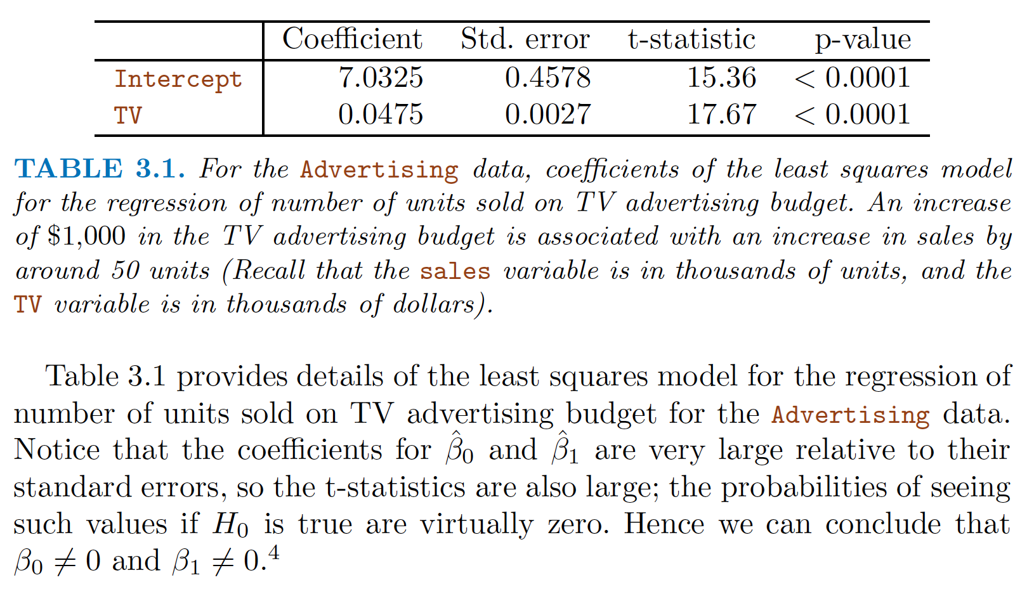

**Assessing the accuracy of model:**

Once we have rejected the null hypothesis in favor of the alternative hypothesis, it is natural to want to quantify the extent to which the model fits the data . The quality of a linear regression fit is typically assessed using two related quantities: the residual standard error (RSE) and the $R^{2}$ statistic.

**Residual Standard Error:** Roughly speaking, it is the average amount that the response will deviate from the true regression line. It is computed using the formula:

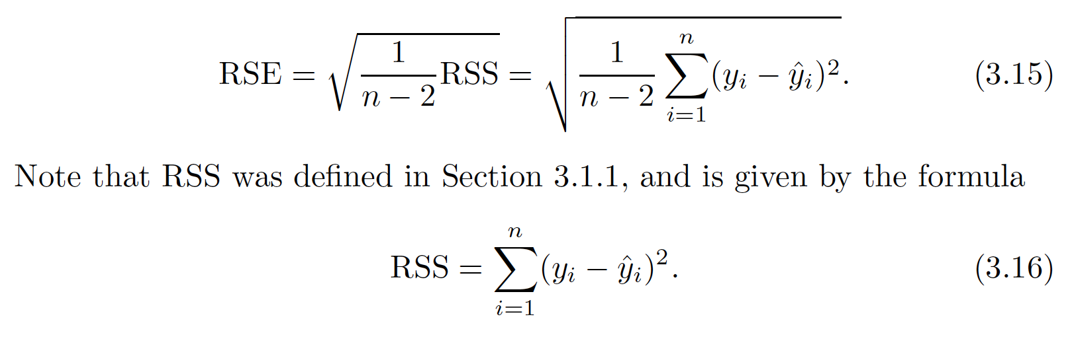

$R^{ 2}$**Statistic:** It takes the form of a proportion —the proportion of variance explained—and so it always takes on a value between 0 and 1, and is independent of the scale of Y .

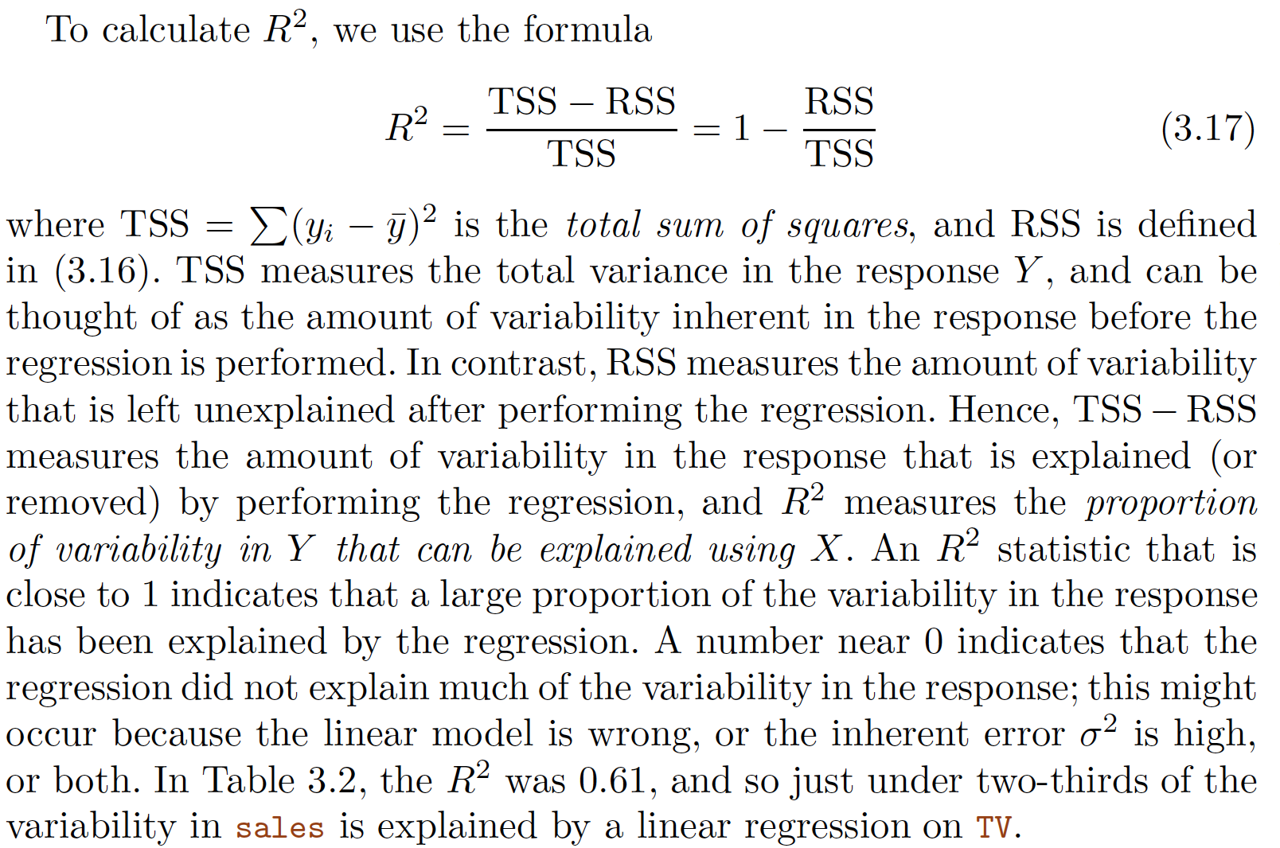

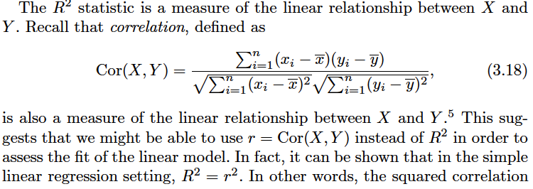

**Multiple Linear Regression:** In practice, we have more than one predictor. One option is two run a single regression line for each predictor. However, the approach of fitting a separate simple linear regression model for each predictor is not entirely satisfactory.

First of all, it is unclear how to make a single prediction from each regression line of different predictor.

Second, each of the regression equations ignores the other predictors in forming estimates for the regression coefficients. We will see shortly that if two predictors are correlated than it will lead to very misleading estimates of the individual predictors.

A better approach is to extend the simple linear regression model so that it can directly accommodate multiple predictors. We can do this by giving each predictor a separate slope coefficient in a single model. In general, suppose that we have p distinct predictors. Then the multiple linear regression model takes the form



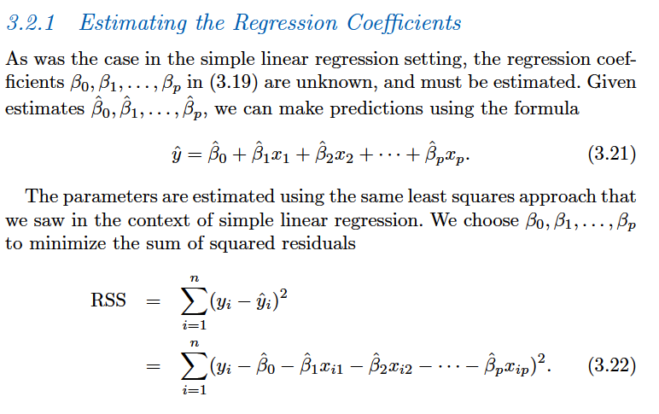

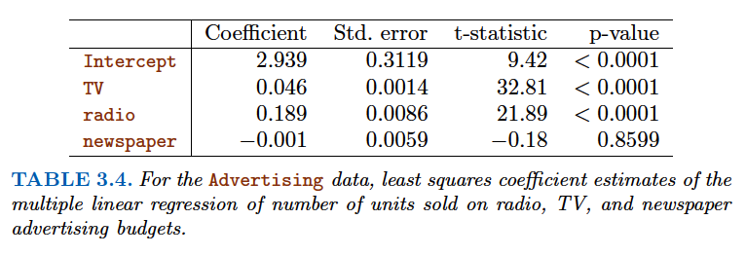

Does it make sense for the multiple regression to suggest no relationship between sales and newspaper while the simple linear regression implies the opposite? In fact it does. Consider the correlation matrix for the three predictor variables and response variable, displayed in Table 3.5. Notice that the correlation between radio and newspaper is 0. 35. This reveals a tendency to spend more on newspaper advertising in markets where more is spent on radio advertising. Now suppose that the multiple regression is correct and newspaper advertising has no direct impact on sales, but radio advertising does increase sales. Then in markets where we spend more on radio our sales will tend to be higher, and as our correlation matrix shows, we also tend to spend more on newspaper advertising in those same markets. Hence, in a simple linear regression which only examines sales versus newspaper , we will observe that higher values of newspaper tend to be

associated with higher values of sales , even though newspaper advertising does not actually affect sales. So newspaper sales are a surrogate for radio advertising; newspaper gets “credit” for the effect of radio on sales . This slightly counterintuitive result is very common in many real life situations. Consider an absurd example to illustrate the point. Running a regression of shark attacks versus ice cream sales for data collected at a given beach community over a period of time would show a positive relationship, similar to that seen between sales and newspaper . Of course no one (yet) has suggested that ice creams should be banned at beaches to reduce shark attacks. In reality, higher temperatures cause more people to visit the beach, which in turn results in more ice cream sales and more shark attacks. A multiple regression of attacks versus ice cream sales and temperature reveals that, as intuition implies, the former predictor is no

longer significant after adjusting for temperature.

When we perform multiple linear regression, we usually are interested in answering a few important questions.

1. Is at least one of the predictors X1,X2, . . . , Xp useful in predicting the response?

2. Do all the predictors help to explain Y , or is only a subset of the predictors useful?

3. How well does the model fit the data?

4. Given a set of predictor values, what response value should we predict, and how accurate is our prediction?

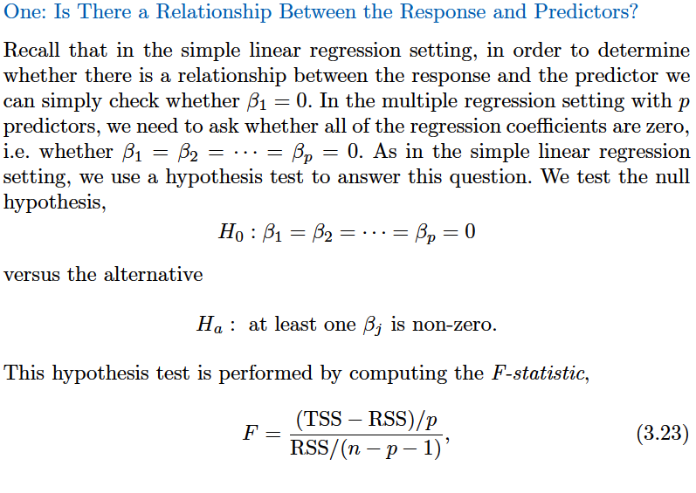

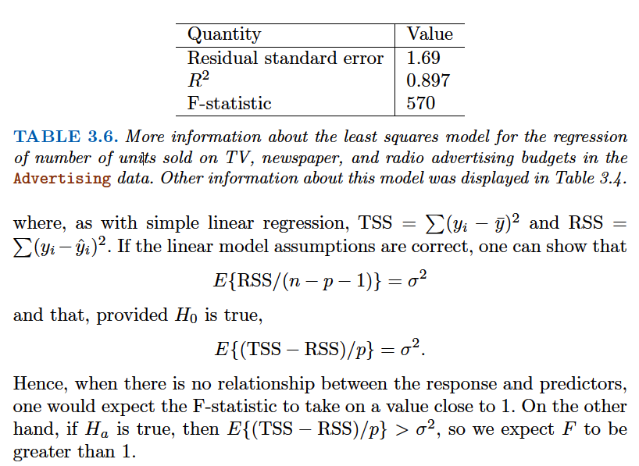

f-statistics = 570 is far larger than 1, it provides compelling evidence against the null hypothesis H0 . In other words, the large F-statistic suggests that at least one of the advertising media must be related to sales.

However, what if the F-statistic had been closer to 1?

How large does the F-statistic need to be before we can reject H0 and conclude that there is a relationship?

When n is large, an F-statistic that is just a little larger than 1 might still provide evidence against H0 . In contrast, a larger F-statistic is needed to reject H0 if n is small. When H0 is true and the errors $∈$ have a normal distribution, the F-statistic follows an F-distribution. For any given value of n and p , any statistical software package can be used to compute the p-value associated with the F-statistic using this distribution. Based on this p-value, we can determine whether or not to reject H0 .

In multiple regression, we have seen p-values for very predictor, how we get it for individual predictore? As above, only gives one p-values.

**Hypothesis testing for a particular subset of q of the coefficients:**

The corresponding null hypothesis:

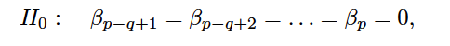

where for convenience we have put the variables chosen for omission at the end of the list. In this case we fit a second model that uses all the variables except those last q . Suppose that the residual sum of squares for that model is RSS0 . Then the appropriate F-statistic is

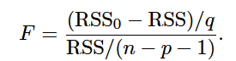

As p-value for each predictor in multiple regression show that predictor is related to response after adjusting for other predictors.

**The square of each t-statistic is the corresponding F-statistic. (given in table 4)**

It turns out that each of these are exactly equivalent to the F-test that omits that single variable from the model, leaving all the others in—i.e. q =1 in (3.24). So it reports the partial effect of adding that variable to the model. For instance, as we discussed earlier, these p-values indicate

that TV and radio are related to sales , but that there is no evidence that newspaper is associated with sales , in the presence of these two.

***Given these individual p-values for each variable, why do we need to look at the overall F-statistic?***

After all, it seems likely that if any one of the p-values for the individual variables is very small, then at least one of the predictors is related to the response . ***However, this logic is flawed, especially when the number of predictors p is large.***

For instance, consider an example in which p = 100 and H0, is true, so no variable is truly associated with the response. In this situation, about 5% of the p-values associated with each variable (of the type shown in Table 3.4) will be below 0. 05 by chance. *In other words, we expect to see approximately five small p-values even in the absence of any true association between the predictors and the response.* In fact, we are almost guaranteed that we will observe at least one p-value below 0. 05 by chance! Hence, if we use the individual t-statistics and associated p-values in order to decide whether or not there is any association between the variables and the response, ***there is a very high chance that we will incorrectly conclude that there is a relationship***. However, the F-statisticdoes not suffer from this problem because it adjusts for the number ofpredictors. Hence, if H0 is true, there is only a 5% chance that the F-statisticwill result in a p-value below 0. 05, regardless of the number ofpredictors or the number of observations.

The approach of using an F-statistic to test for any association between the predictors and the response works when *p is relatively small* compared to n . However, sometimes we have a very large number of variables. If p > n then there are more coefficients βj to estimate than observations from which to estimate them. In this case we cannot even fit the multiple linear regression model using least squares, so the F-statistic cannot be used, and neither can most of the other concepts that we have seen so far in this chapter. When p is large, some of the approaches discussed in the next section, such as forward selection , can be used. This high-dimensional setting is discussed in greater detail.

**Two: Deciding on Important Variables:**

1. Overall F-statistic and p-value determine whether atleast one predictor in model is related to response or not.

2. But if want to know which are important one we can look at individual F-statistic/t-statistic (F=square(t)) for predictors, but as discussed before if number of predictors (p) are large, some p-values will fall below significant level 0.05 by chance ( not because they are significant). 5 times out of 100 predictors, 5%.

***Then how can we determine which predictors are associated with the response, in order to fit a single model involving only those predictors? Using Variable Selection***

***Variable Selection:*** We can try out different subsets of p predictors and make a model on this subset of predictors so there will be $2^{p}$ models. This means that even for moderate p, trying out every possible subset is infeasible. For p=30 then 1,073,741,824 models! This is not practical.

We need an automated and efficient approaches:

* **Forward Selection:** Start with null model ( only intercept, mean) call this level 0 model. Make simple linear regression for every predictor and for whatever predictor regression has lowest RSS add that predictor to the null model call this model level 1 model. Now add the predictor to the level 1 model which results in lowest RSS, if we make linear regression on each remained predictor and the predictor of level 1 model. Result model would be level 2 model. This approach is continued until some stopping rule is satisfied.
* **Backward Selection:** We start with all variables in the model, and remove the variable with the largest p-value—that is, the variable that is the least statistically significant. The new (p − 1)-variable model is fit, and the variable with the largest p-value is removed. This procedure continues until a stopping rule is reached. For instance, we may stop when all remaining variables have a p-value below some threshold.
* **Mixed Selection:** This is a combination of forward and backward selection. We start with no variables in the model, and as with forward selection selection, we add the variable that provides the best fit. We continue to add variables one-by-one. Of course, as we noted with the Advertising example, the p-values for variables can become larger as new predictors are added to the model. Hence, if at any point the p-value for one of the variables in the model rises above a certain threshold, then we remove that variable from the model. We continue to perform these forward and backward steps until all variables in the model have a sufficiently low p-value, and all variables outside the model would have a large p-value if added to the model.

*Backward selection cannot be used if p > n , while forward selection can always be used.*

*Forward selection is a greedy approach, and might include variables early that later become redundant. Mixed selection can remedy this.*

**Three: Model Fit**

In multiple linear regression, it turns out that $R^{2}$ equals Cor(Y, ˆY )2 , the square of the correlation between the response and the fitted linear model. It turns out that $R^{2}$ will always increase when more variable are added to the model, even if those variables are only weakly associated with the response. This is due to the fact that adding another variable to the least squares equations must allow us to fit the training data (though not necessarily the testing data) more accurately. Essentially, if a predictore provides no real improvement in the model fit to the training samples, and its inclusion will likely lead to poor results on independent test samples due to overfitting.

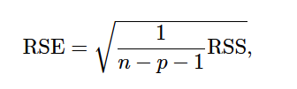

Thus, models with more variables can have higher RSE if the decrease in RSS is small relative to the increase in p.

To assess importance of different predictors, we can use RSE, $R^{2}$ and p-values. Also, it can be useful to plot the data that can reveal problems with model that are not visible with numerical statistics.

***Synergy or Interaction effect:***

For example, Figure 3.5 displays a three-dimensional plot of TV and radio versus sales . We see that some observations lie above and some observations lie below the least squares regression plane. In particular, the linear model seems to overestimate sales for instances in which most of the advertising money was spent exclusively on either TV or radio . It underestimates sales for instances where the budget was split between the two media. This pronounced non-linear pattern cannot be modeled accurately using linear regression. It suggests a ***synergy or interaction effect*** between the advertising media, whereby combining the media together results in a bigger boost to sales than using any single medium.

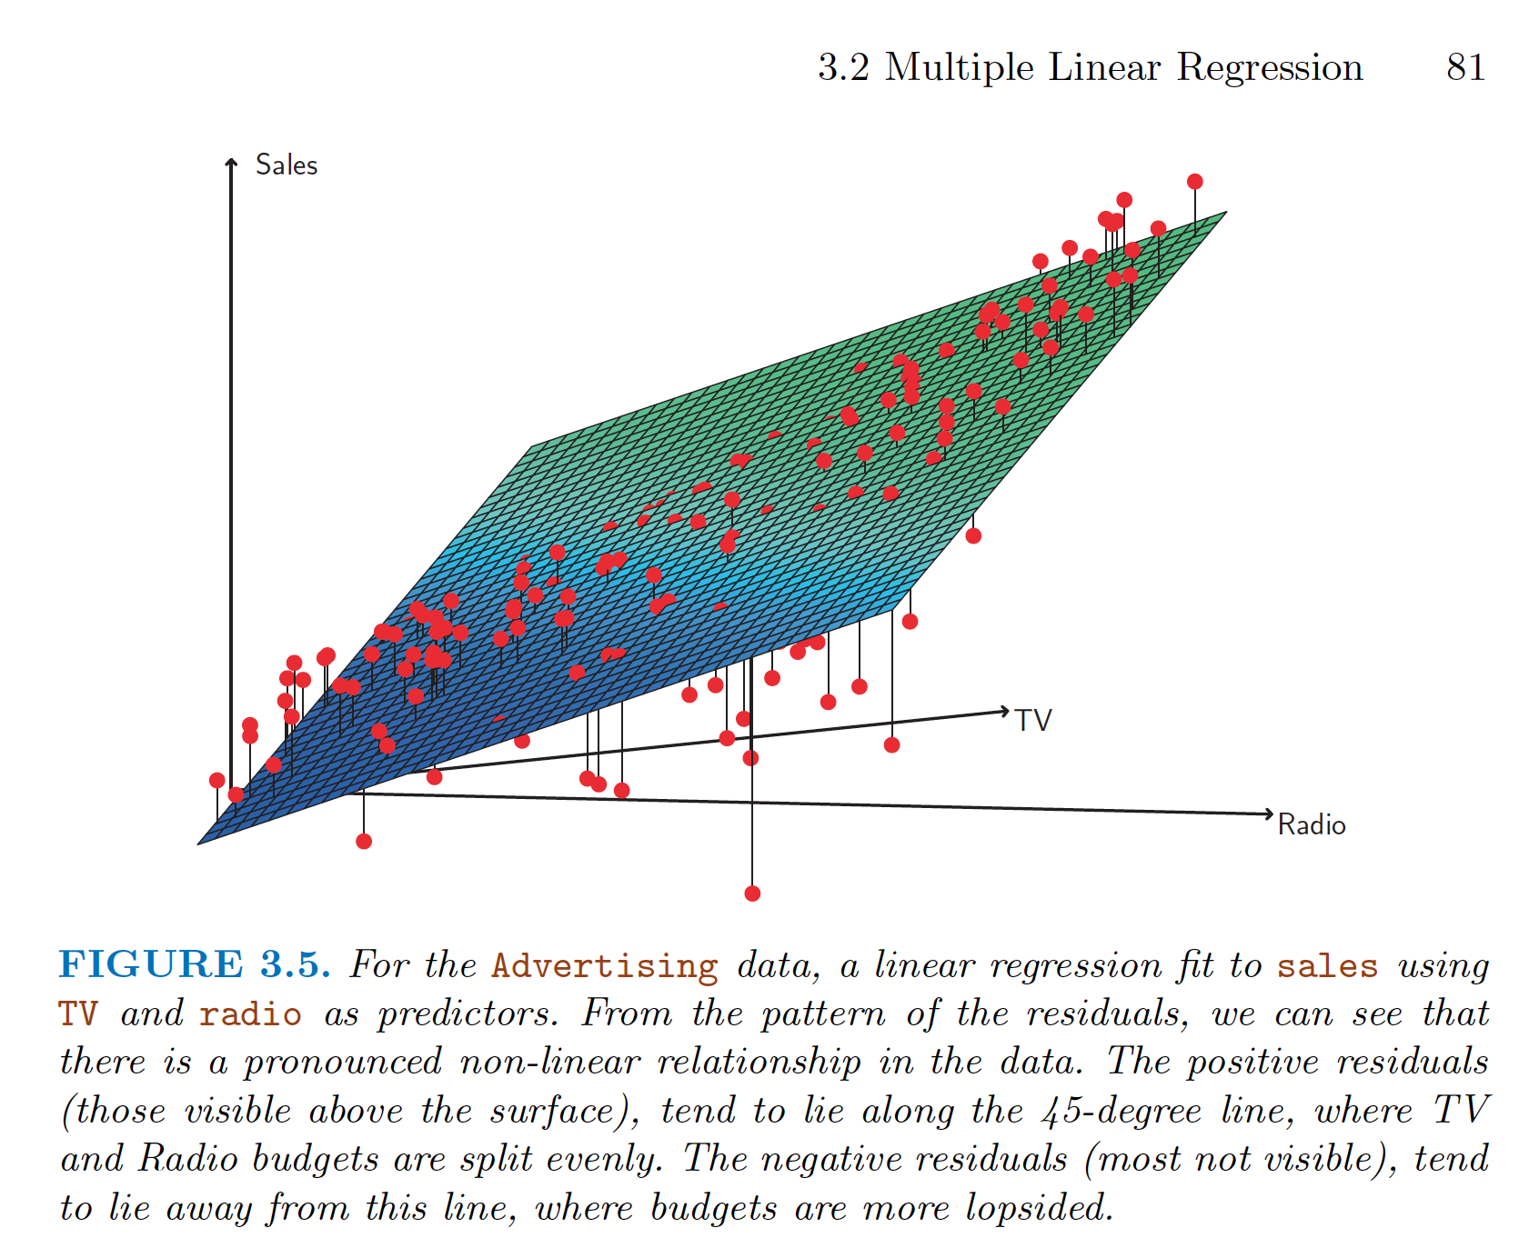

**Four: Predictions**

Once we have fitted the linear regression model, it is straightforward to apply in order to predict the response Y on the basis of set of values of predictors Xi. However, there are three sorts of uncertainty associated with this predictions.

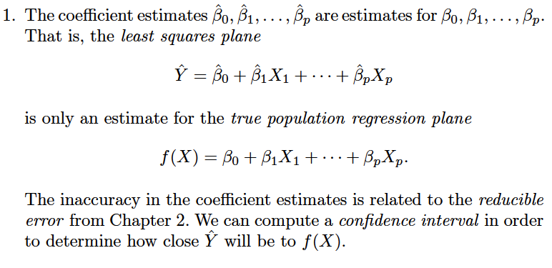

2. **Model Bias** : Assuming a linear model for f(x) is almost an approximation of reality, so there is an additional source of potentially reducible error.

3. **Irreducible error/ random error $∈$,** how much Y will vary from $^Y$ (Y hat)? We use *prediction intervals* to answer this question. Prediction intervals are always wider than confidence intervals.

**Other Consideration in the Regression Models:**

**Qualitative Predictors:**

Suppose that we wish to investigate differences in credit card balance between males and females. We simply create an indicator or dummy variable that takes on two possible numerical values. For example, based on the gender variable, we can create variable a new variable that takes the form:

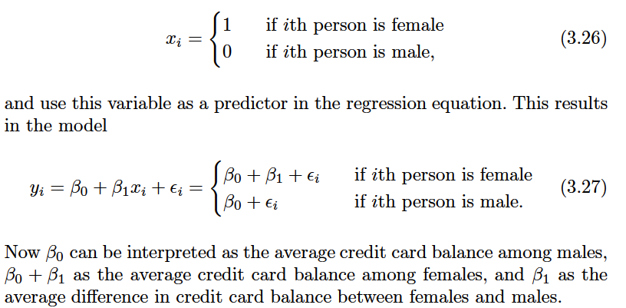

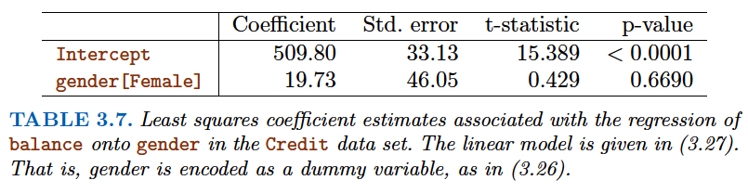

However, we notice that the p-value for the dummy variable is very high. This indicates that there is no statistical evidence of a difference in average credit card balance between the genders.

There is another choice of coding 1/-1:

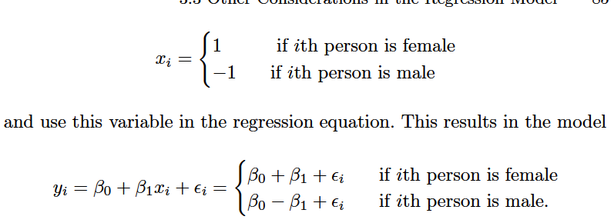

**For more than one qualitative predictor:**

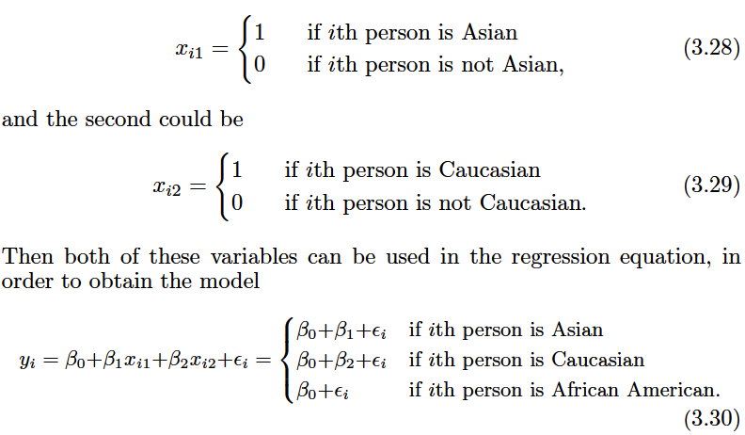

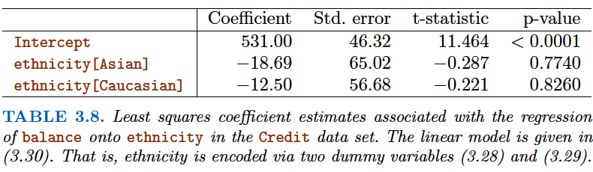

Once again, the level selected as the baseline category is arbitrary, and the final predictions for each group will be the same regardless of this choice. However, the coefficients and their p-values do depend on the choice of dummy variable coding. Rather than rely on the individual coefficients, we can use an F-test to test H0 : β1 = β2 = 0; this does not depend on the coding.

This F-test has a p-value of 0. 96, indicating that we cannot reject the null hypothesis that there is no relationship between balance and ethnicity .

**Extensions of the Linear Model:**

**Removing the Additive Assumption:**

In our previous analysis of the Advertising data, we concluded that both TV and radio seem to be associated with sales . The linear models that formed the basis for this conclusion assumed that the effect on sales of increasing one advertising medium is independent of the amount spent on the other media. For example, the linear model (3.20) states that the average effect on sales of a one-unit increase in TV is always β1 , regardless of the amount spent on radio .

However, this simple model may be incorrect. In this situation, given a fixed budget of $100000, spending half on radio and half on TV may increase sales more than allocating the entire amount to either TV or to radio . In marketing, this is known as a ***synergy effect***, and in statistics it is referred to as an ***interaction effect.***

One way of extending this model to allow for interaction effects is to include a third predictor, called an interaction term , which is constructed by computing the product of X1 and X2 . This results in the model:

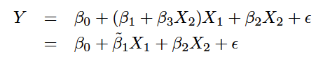

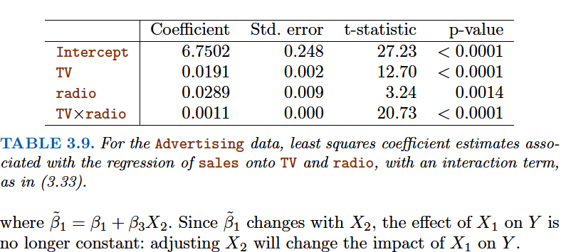

For example, suppose that we are interested in studying the productivity of a factory. We wish to predict the number of units produced on the basis of the number of production lines and the total number of workers . It seems likely that the effect of increasing the number of production lines will depend on the number of workers, since if no workers are available to operate the lines, then increasing the number of lines will not increase production. This suggests that it would be appropriate to include an interaction term between lines and workers in a linear model to predict units . Suppose that when we fit the model, we obtain:

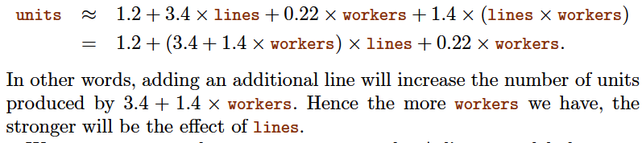

We now return to the Advertising example. A linear model that uses radio , TV , and an interaction between the two to predict sales takes the form:

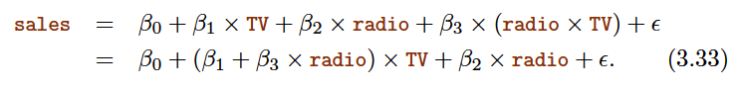

We can interpret β3 as the increase in the effectiveness of TV advertising for a one unit increase in radio advertising (or vice-versa). In Table 3.9. Interaction term is superior to the model that contains only main effects . The p-value for the interaction term, TV $X$ radio , is extremely low, indicating that there is strong evidence for Ha : β3 _ = 0. In other words, it is clear that the true relationship is not additive. The R2 for the model (3.33) is 96.8%, compared to only 89.7% for the model that predicts sales using TV and radio without an interaction term. This means that (96. 8 − 89. 7)/ (100 − 89. 7) = 69% of the variability in sales that remains after fitting the additive model has been explained by the interaction term.

** However, it is sometimes the case that an interaction term has a very small p-value, but the associated main effects (in this case, TV and radio ) do not. ***The hierarchical principle states that if we include an interaction in a model, we hierarchical should also include the main effects, even if the p-values associated with principle their coefficients are not significant.***

X1 * X2 is typically correlated with X1 and X2, and so leaving them out tends to alter the meaning of the interaction.

**Interaction with qualitative variables:** Consider two predictors one is the income (quantitative) second is student (qualitative). In the absence of an interaction term, the model takes the form

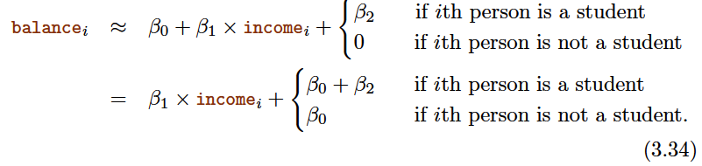

Notice that this amounts to fitting two parallel lines to the data, one for students (with intercept β0 + β2) and one for non-students ( with intercept β0) but with same slope β1. ***This represents potentially serious limitation of the model, since in fact a change in income may have a very different effect on the credit card balance of a student versus a non-student.***

This limitation can be addressed by adding an interaction variable, created by multiplying income with the dummy variable for student.

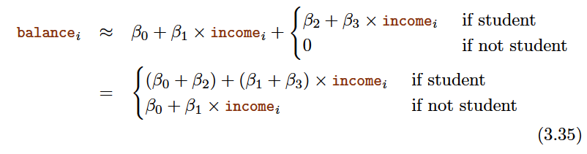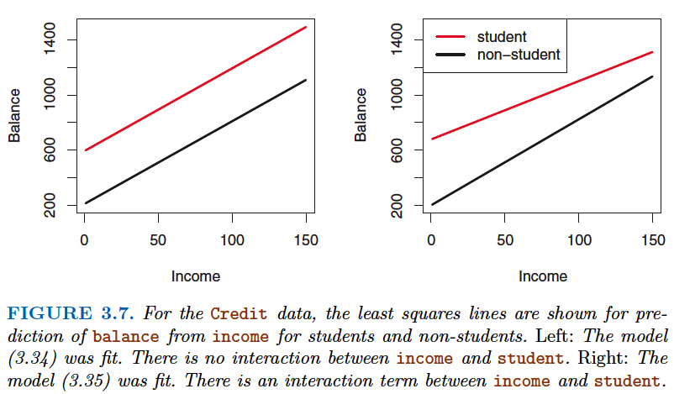

**Non-linear Relationships: Polynomial Regression**

In some cases, the true relationship between the response and the predictors may be nonlinear.

Here we present a very simple way to directly extend the linear model to accommodate non-linear relationships, using polynomial regression . In later chapters, we will present more complex approaches for performing non-linear fits in more general settings.

For example, the points in Figure 3.8 seem to have a quadratic shape, suggesting that a model of the form may provide a better fit. Equation 3.36 involves predicting mpg using a non-linear function of horsepower . But it is still a linear model! That is, (3.36) is simply a multiple linear regression model with X1 = horsepower and X2 = horsepower2 . So we can use standard linear regression software to estimate β0, β1 , and β2 in order to produce a non-linear fit.

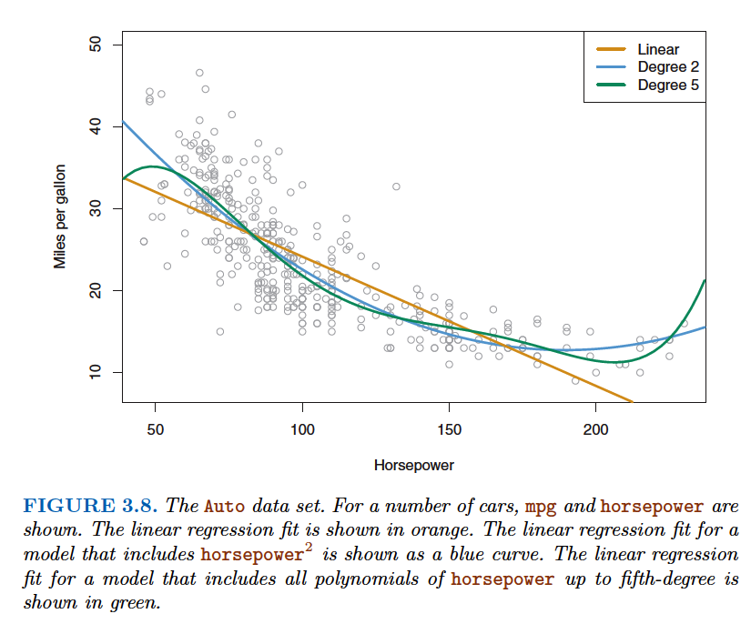

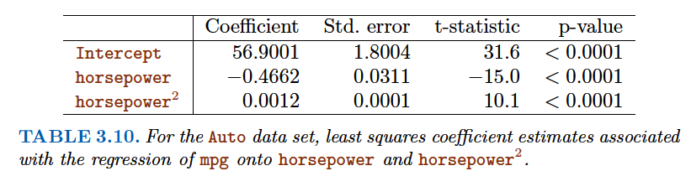

**Potential Problems :**

1. Non-linearity of the response-predictor relationships.

2. Correlation of error terms.

3. Non-constant variance of error terms.

4. Outliers.

5. High-leverage points.

6. Collinearity.

1. Non-linearity of the response-predictor relationships.

Residual plots are a useful graphical tool for identifying non-linearity. Given a simple linear regression model, we can plot the residuals, ei = yi − ˆyi, versus the predictor xi. In the case of a multiple regression model, since there are multiple predictors, we instead plot the residuals versus the predicted (or fitted ) values ˆyi . Ideally, the residual plot will show no discernible pattern. The presence of a pattern may indicate a problem with some aspect of the linear model.

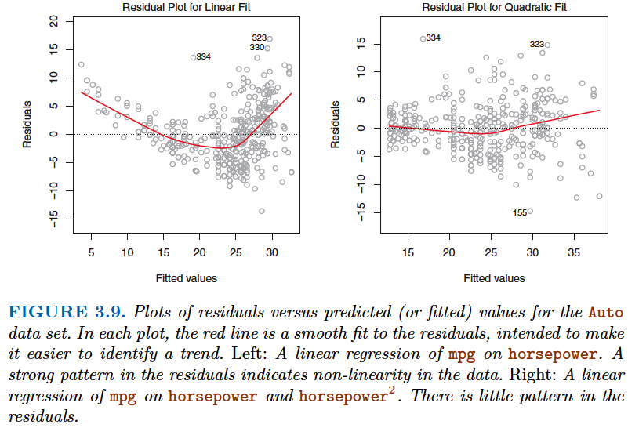

The red line is a smooth fit to the residuals, which is displayed in order to make it easier to identify any trends. The residuals exhibit a clear U-shape, which provides a strong indication of non-linearity in the data. In contrast, the right-hand panel of Figure 3.9 displays the residual plot that results from the model (3.36), which contains a quadratic term. There appears to be little pattern in the residuals, suggesting that the quadratic term improves the fit to the data.

If the residual plot indicates that there are non-linear associations in the data, then a simple approach is to use non-linear transformations of the predictors, such as logX ,√X , and X2 , in the regression model.

2. Correlation of error terms: (Frequently occurs in Time Series)

An important assumption of the linear regression model is that the error terms, $∈$_1, $∈$_2, . . . , $∈$_n , are uncorrelated. What does this mean? For instance, if the errors are uncorrelated, then the fact that $∈$_i is positive provides little or no information about the sign of $∈$_i+1 . The standard errors that are computed for the estimated regression coefficients or the fitted values are based on the assumption of uncorrelated error terms. If in fact there is correlation among the error terms, then the estimated standard errors will tend to underestimate the true standard errors. As a result, confidence and prediction intervals will be narrower than they should be. For example, a 95% confidence interval may in reality have a much lower probability than 0. 95 of containing the true value of the parameter. In addition, p-values associated with the model will be lower than they should be; this could cause us to erroneously conclude that a parameter is statistically significant. ***In short, if the error terms are correlated, we may have an***

***unwarranted sense of confidence in our model.***

As an extreme example, suppose we accidentally doubled our data, leading to observations and error terms identical in pairs. If we ignored this, our standard error calculations would be as if we had a sample of size 2n , when in fact we have only n samples. Our estimated parameters would be the same for the 2n samples as for the n samples, but the confidence intervals would be narrower by a factor of √2!.

Correlation among the error terms can also occur outside of time series data. For instance, consider a study in which individuals’ heights are predicted from their weights. The assumption of uncorrelated errors could be violated if some of the individuals in the study are members of the same family, or eat the same diet, or have been exposed to the same environmental factors. In general, the assumption of uncorrelated errors is extremely important for linear regression as well as for other statistical methods, and good experimental design is crucial in order to mitigate the risk of such correlations.

3. Non-constant variance of error terms:

Another important assumption of the linear regression model is that the error terms have a constant variance, Var($∈$_i ) = σ2 . The standard errors, confidence intervals, and hypothesis tests associated with the linear model rely upon this assumption.

One can identify non-constant variances in the errors, or heteroscedasticity , from the presence of a funnel shape in the residual plot. When faced with this problem, one possible solution is to transform the response Y using a concave function such as log Y or √Y . Such a transformation results in a greater amount of shrinkage of the larger responses, leading to a reduction in heteroscedasticity.

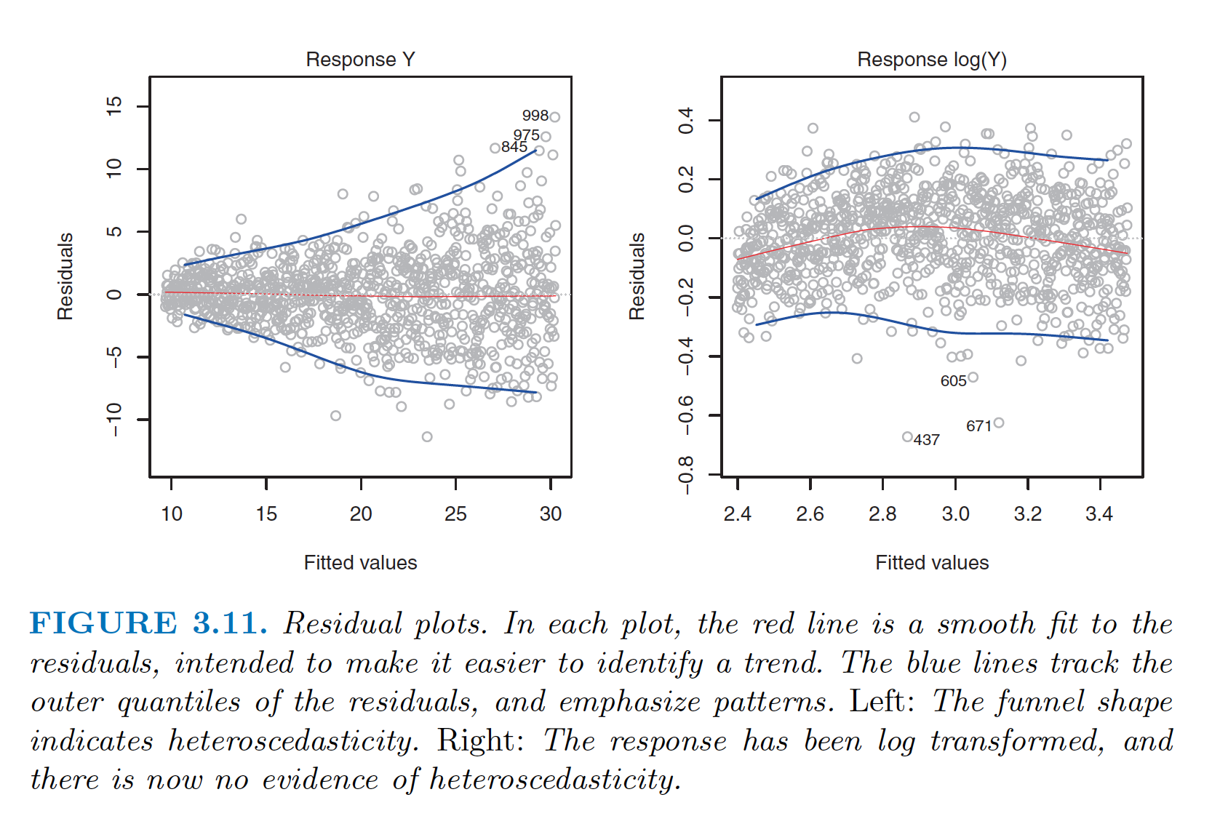

The residuals now appear to have constant variance, though there is some evidence of a slight non-linear relationship in the data.

4. Outliers:

An outlier is a point for which yi is far from the value predicted by the model.

In this case, removing the outlier has little effect on the least squares line: it leads to almost no change in the slope, and a miniscule reduction in the intercept. It is typical for an outlier that does not have an unusual predictor value to have little effect on the least squares fit. However, even if an outlier does not have much effect on the least squares fit, it can cause other problems. For instance, in this example, the RSE is 1. 09 when the outlier is included in the regression, but it is only 0. 77 when the outlier is removed. Since the RSE is used to compute all confidence intervals and p-values, such a dramatic increase caused by a single data point can have implications for the interpretation of the fit. Similarly, inclusion of the outlier causes the R2 to decline from 0. 892 to 0. 805.

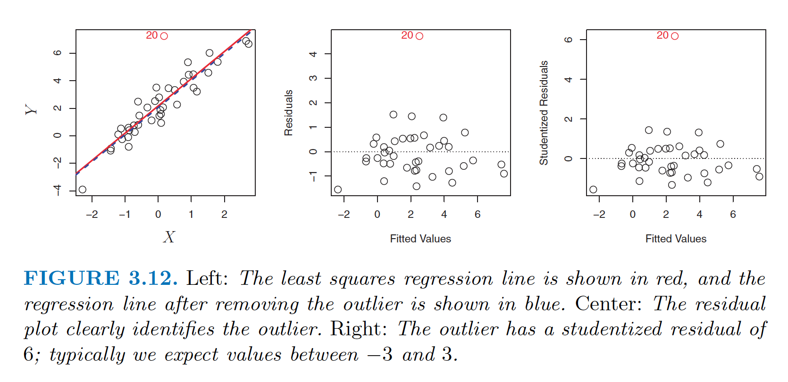

***How to identify the outliers?:*** Residual plots can be used to identify outliers.

***How large a residual needs to be before we consider the point to be an outlier? :*** We can plot the studentized residuals , computed by dividing each residual ei by its estimated standard error. Observations whose studentized residuals are greater than 3 in abso-lute value are possible outliers.

**What to do with outliers?** If we believe that an outlier has occurred due to an error in data collection or recording, then one solution is to simply remove the observation. However, care should be taken, since an outlier may instead indicate a deficiency with the model, such as a missing predictor.

5. High-leverage points:

outliers are observations for which the response yi is unusual given the predictor xi . In contrast, observations with high leveragehave an unusual value for xi .

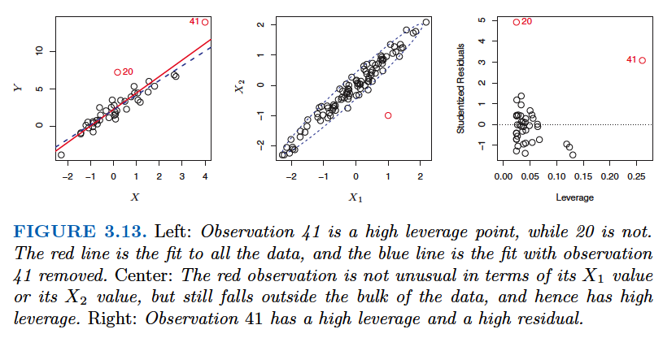

Comparing the left-hand panels of Figures 3.12 and 3.13, we observe that removing the high leverage observation has a much more substantial impact on the least squares line.

But in a multiple linear regression with many predictors, it is possible to have an observation

that is well within the range of each individual predictor’s values, but that is unusual in terms of the full set of predictors. An example is shown in the center panel of Figure 3.13, for a data set with two predictors, X1 and X2 . Most of the observations’ predictor values fall within the blue dashed ellipse, but the red observation is well outside of this range. But neither its value for X1 nor its value for X2 is unusual. So if we examine just X1 or just X2 , we will fail to notice this high leverage point.

**Leverage Statistic,** For a simple linear regression:

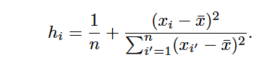

The leverage statistic hi is always between 1/n and 1, and the average leverage for all the observations is always equal to (p +1)/n . So if a given observation has a leverage statistic that greatly exceeds (p +1)/n , then we may suspect that the corresponding point has high leverage.

**6. Collinearity: (Multicollinearity for more than two predictors)**

***Collinearity refers to the situation in which two or more predictor variables are closely related to one another.***

The presence of collinearity can pose problems in the regression context, since it can be difficult to separate out the individual effects of collinear variables on the response.

The right-hand panel of Figure 3.15 displays ***contour plots of the RSS*** associated with possible coefficient estimates for the regression of balance onto limit and rating , which we know to be highly collinear. Now the contours run along a narrow valley; there is a broad range of values for the coefficient estimates that result in equal values for RSS. Hence a small change in the data could cause the pair of coefficient values that yield the smallest RSS—that is, the least squares estimates—to move anywhere along this valley. This results in a great deal of uncertainty in the coefficient estimates. Notice that the scale for the limit coefficient now runs

from roughly − 0. 2 to 0. 2; this is an eight-fold increase over the plausible range of the limit coefficient in the regression with age . Interestingly, even though the limit and rating coefficients now have much more individual uncertainty, they will almost certainly lie somewhere in this contour valley. For example, we would not expect the true value of the limit and rating coefficients to be − 0. 1 and 1 respectively, even though such a value is

plausible for each coefficient individually.

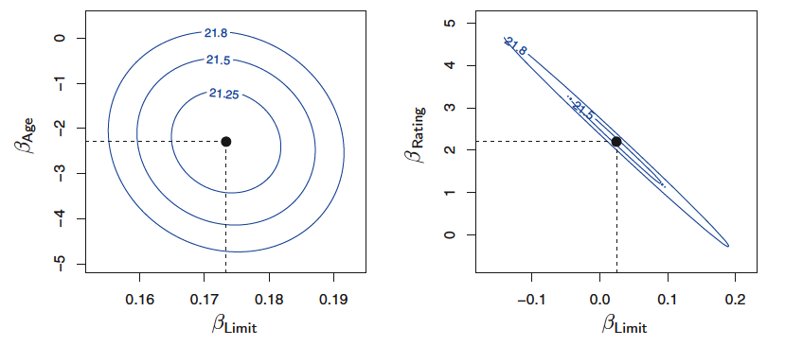

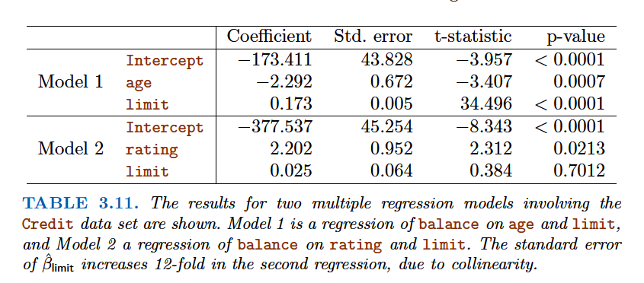

Since collinearity reduces the accuracy of the estimates of the regression coefficients, it causes the standard error for ˆβj to grow. Recall that the t -statistic for each predictor is calculated by dividing ˆ βj by its standard error. Consequently, collinearity results in a decline in the t -statistic. As a result, in the presence of collinearity, we may fail to reject H0 : βj = 0. This

means that the power of the hypothesis test—the probability of correctly power detecting a non-zero coefficient—is reduced by collinearity.

**How to detect multi-collinearity:**

**1.** Look at the correlation matrix of the predictors. Unfortunately, not all collinearity problems can be detected by inspection of the correlation matrix: it is possible for collinearity to exist between three or more variables even if no pair of variables has a particularly high correlation. We call this situation multicollinearity .

2. To assess multi-collinearity is to compute the ***variance inflation factor (VIF).***

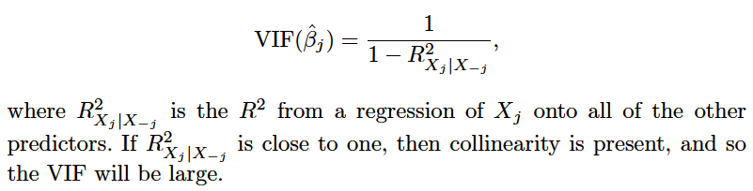

where *R*2*i* is the [coefficient of determination](https://en.wikipedia.org/wiki/Coefficient_of_determination) of the regression equation in step one, with {\displaystyle X_{i}} on the left hand side, and all other predictor variables (all the other X variables) on the right hand side.

**How to deal with multicollinearity:**

1. Drop one of the probalmatic variable, see R2 values and other factors like rmse, p-value etc

2. The second solution is to combine the collinear variables together into a single predictor. For instance, we might take the average of standardized versions of limit and rating in order to create a new variable that measures credit worthiness.

**Some common questions on Linear Regression:**

1. Is there a relationship between advertising sales and budget?

This question can be answered by fitting a multiple regression model

of sales onto TV , radio , and newspaper , as in (3.20), and testing the

hypothesis H0 : βTV = βradio = βnewspaper = 0. In Section 3.2.2,

we showed that the F-statistic can be used to determine whether or

not we should reject this null hypothesis. In this case the p-value

corresponding to the F-statistic in Table 3.6 is very low, indicating

clear evidence of a relationship between advertising and sales.

2. How strong is the relationship?

We discussed two measures of model accuracy in Section 3.1.3. First,

the RSE estimates the standard deviation of the response from the

population regression line. For the Advertising data, the RSE is 1, 681

units while the mean value for the response is 14, 022, indicating a

percentage error of roughly 12%. Second, the R2 statistic records

the percentage of variability in the response that is explained by

the predictors. The predictors explain almost 90% of the variance in

sales . The RSE and R2 statistics are displayed in Table 3.6.

3. Which media contribute to sales?

To answer this question, we can examine the p-values associated with

each predictor’s t-statistic (Section 3.1.2). In the multiple linear regression

displayed in Table 3.4, the p-values for TV and radio are low,

but the p-value for newspaper is not. This suggests that only TV and

radio are related to sales . In Chapter 6 we explore this question in

greater detail.

4. How large is the effect of each medium on sales?

We saw in Section 3.1.2 that the standard error of ˆ βj can be used

to construct confidence intervals for βj . For the Advertising data,

the 95% confidence intervals are as follows: (0. 043, 0. 049) for TV ,

(0. 172, 0. 206) for radio , and (− 0. 013, 0. 011) for newspaper . The confidence

intervals for TV and radio are narrow and far from zero, providing

evidence that these media are related to sales . But the interval

for newspaper includes zero, indicating that the variable is not statistically

significant given the values of TV and radio .

We saw in Section 3.3.3 that collinearity can result in very wide standard

errors. Could collinearity be the reason that the confidence interval

associated with newspaper is so wide? The VIF scores are 1. 005,

1. 145, and 1. 145 for TV , radio , and newspaper , suggesting no evidence

of collinearity.

In order to assess the association of each medium individually on

sales, we can perform three separate simple linear regressions. Results

are shown in Tables 3.1 and 3.3. There is evidence of an extremely

strong association between TV and sales and between radio

and sales . There is evidence of a mild association between newspaper

and sales , when the values of TV and radio are ignored.

5. How accurately can we predict future sales?

The response can be predicted using (3.21). The accuracy associated

with this estimate depends on whether we wish to predict an

individual response, Y = f (X ) + _ , or the average response, f (X )

(Section 3.2.2). If the former, we use a prediction interval, and if the

latter, we use a confidence interval. Prediction intervals will always

be wider than confidence intervals because they account for the uncertainty

associated with _ , the irreducible error.

6. Is the relationship linear?

In Section 3.3.3, we saw that residual plots can be used in order to

identify non-linearity. If the relationships are linear, then the residual

plots should display no pattern. In the case of the Advertising data,

we observe a non-linear effect in Figure 3.5, though this effect could

also be observed in a residual plot. In Section 3.3.2, we discussed the

inclusion of transformations of the predictors in the linear regression

model in order to accommodate non-linear relationships.

7. Is there synergy among the advertising media?

The standard linear regression model assumes an additive relationship

between the predictors and the response. An additive model is

easy to interpret because the effect of each predictor on the response is

unrelated to the values of the other predictors. However, the additive

assumption may be unrealistic for certain data sets. In Section 3.3.2,

we showed how to include an interaction term in the regression model

in order to accommodate non-additive relationships. A small p-value

associated with the interaction term indicates the presence of such

relationships. Figure 3.5 suggested that the Advertising data may

not be additive. Including an interaction term in the model results in

a substantial increase in R2 , from around 90% to almost 97%.

**KNN Regression:**

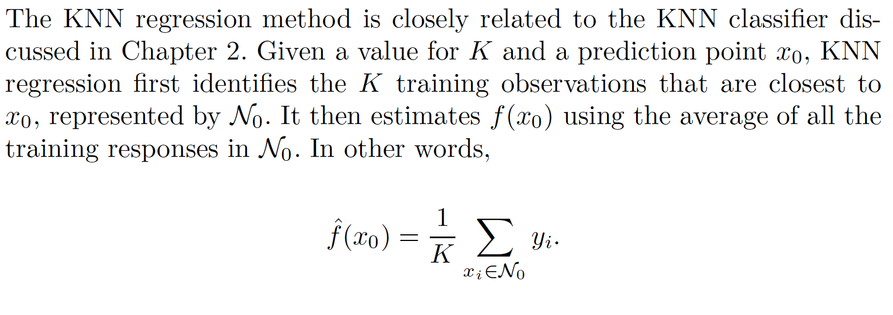

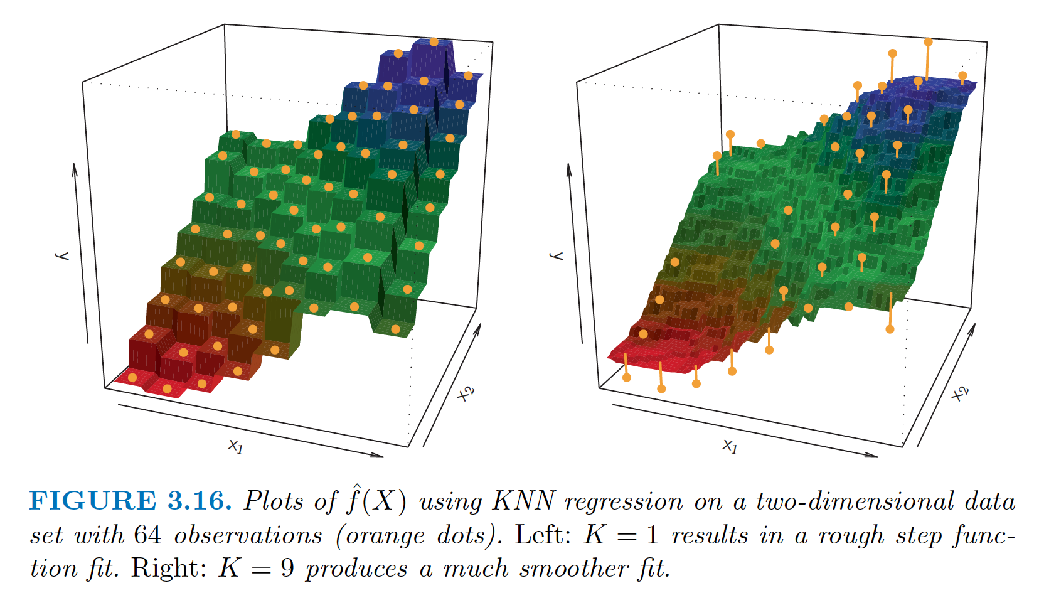

In general, the optimal value for K will depend on the bias-variance tradeoff , which we introduced in Chapter 2. A small value for K provides the most flexible fit, which will have low bias but high variance. This variance is due to the fact that the prediction in a given region is entirely dependent on just one observation. In contrast, larger values of K provide a smoother and less variable fit; the prediction in a region is an average of several points, and so changing one observation has a smaller effect. However, the smoothing may cause bias by masking some of the structure in f (X ). In Chapter 5, we introduce several approaches for estimating test error rates. These methods can be used to identify the optimal value of K in KNN regression.

***In what setting will a parametric approach such as least squares linear regression outperform a non-parametric approach such as KNN regression?***

The answer is simple: the parametric approach will outperform the nonparametric approach if the parametric form that has been selected is close to the true form of f, because a non-parametric approach incurs a cost in variance that is not offset by a reduction in bias. Also if the number of predictor is large, parametric approach will work better than non-parametric approach because of a phenomenon called ***curse of dimensionality*** which id going to come ahead in this section.

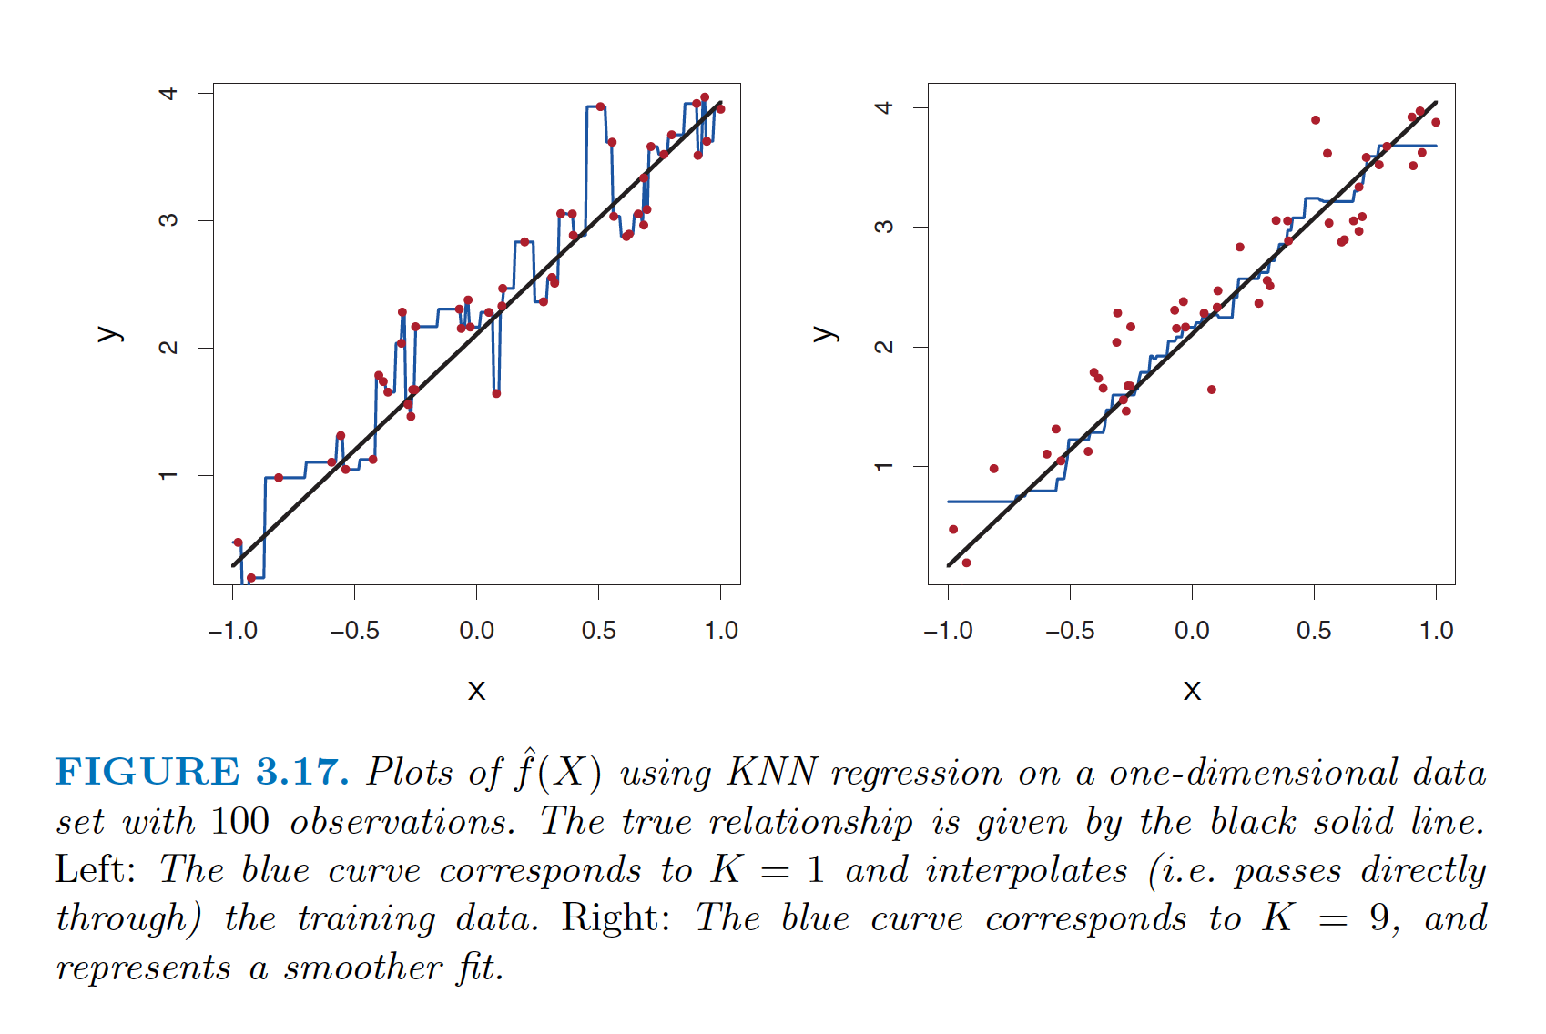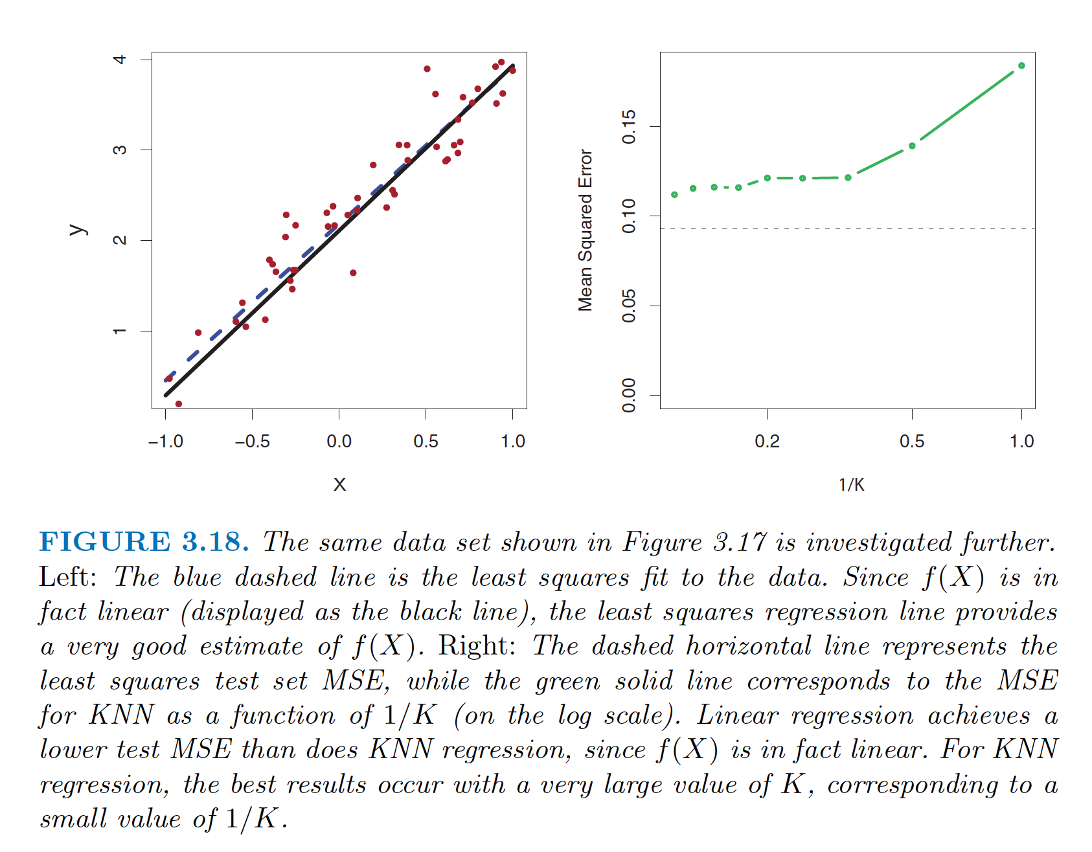

***In above graph, the true relationship is linear, it is hard for a non-parametric approach to compete with linear regression: a non-parametric approach incurs a cost in variance that is not offset by a reduction in bias.***

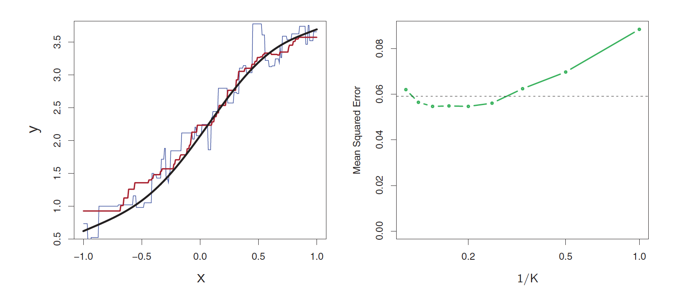

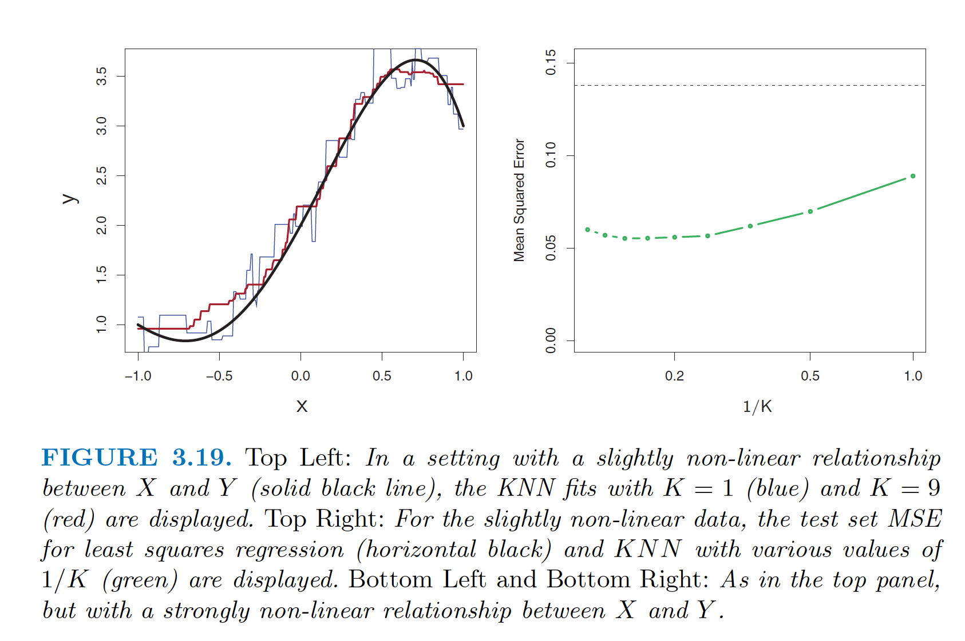

***In practice, the true relationship between X and Y is rarely exactly linear. In first graph, data is nearly linear (not linear) so KNN outperforms Least square method for K>=4.***

***Note that as the extent of non-linearity increases, there is little change in the test set MSE for the non-parametric KNN method, but there is a large increase in the test set MSE of linear***

***regression.***

**KNN is still worse then Least squares if number of predictor is large:**

In a real life situation in which the true relationship is unknown, one might draw the conclusion that KNN should be favored over linear regression because it will at worst be slightly inferior than linear regression if the true relationship is linear, and may give substantially better results if the true relationship is non-linear. But in reality, even when the true relationship is highly non-linear, KNN may still provide inferior results to linear regression.

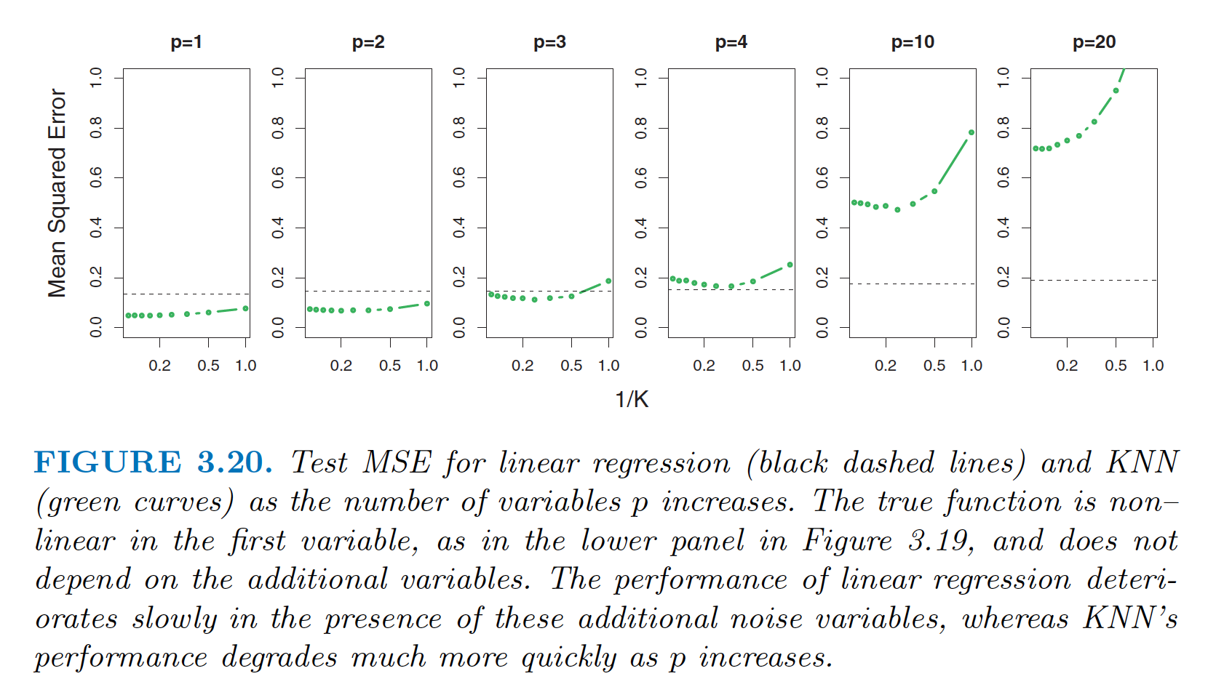

However, spreading 100 observations over p = 20 dimensions results in a phenomenon in which a given observation has no nearby neighbors —this is the so-called curse of dimensionality . That is, the K observations that are nearest to a given test observation x0 may be very far away from x0 in p -dimensional space when p is large, leading to a very poor prediction of f (x0 ) and hence a poor KNN fit. As a general rule, parametric methods will tend to outperform non-parametric approaches when there is a small number of observations per predictor. Even in problems in which the dimension is small, we might prefer linear regression to KNN from an interpretability standpoint.

If the test MSE of KNN is only slightly lower than that of linear regression, we might be willing to forego a little bit of prediction accuracy for the sake of a simple model that can be described in terms of just a few coefficients, and for which p-values are available.

In [statistics](https://en.wikipedia.org/wiki/Statistics), the **generalized linear model** (**GLM**) is a flexible generalization of ordinary [linear regression](https://en.wikipedia.org/wiki/Linear_regression) that allows for response variables that have error distribution models other than a [normal distribution](https://en.wikipedia.org/wiki/Normal_distribution). The GLM generalizes linear regression by allowing the linear model to be related to the response variable via a *link function* and by allowing the magnitude of the variance of each measurement to be a function of its predicted value.

Generalized linear models were formulated by [John Nelder](https://en.wikipedia.org/wiki/John_Nelder) and [Robert Wedderburn](https://en.wikipedia.org/wiki/Robert_Wedderburn_(statistician)) as a way of unifying various other statistical models, including [linear regression](https://en.wikipedia.org/wiki/Linear_regression), [logistic regression](https://en.wikipedia.org/wiki/Logistic_regression) and [Poisson regression](https://en.wikipedia.org/wiki/Poisson_regression).[[1]](https://en.wikipedia.org/wiki/Generalized_linear_model#cite_note-1) They proposed an [iteratively reweighted least squares](https://en.wikipedia.org/wiki/Iteratively_reweighted_least_squares) [method](https://en.wikipedia.org/wiki/Iterative_method) for [maximum likelihood](https://en.wikipedia.org/wiki/Maximum_likelihood) estimation of the model parameters. Maximum-likelihood estimation remains popular and is the default method on many statistical computing packages. Other approaches, including [Bayesian approaches](https://en.wikipedia.org/wiki/Bayesian_statistics) and [least squares](https://en.wikipedia.org/wiki/Least_squares) fits to [variance stabilized](https://en.wikipedia.org/wiki/Variance-stabilizing_transformation) responses, have been developed.